The Republic of Serbia

Improving Public Financial Management for the Green Transition (P175655)

Draft
ENVIRONMENTAL and SOCIAL
COMMITMENT PLAN (ESCP)

November 2022

ENVIRONMENTAL AND SOCIAL COMMITMENT PLAN

- The Republic of Serbia (the Borrower/Recipient) will implement the Improving Public Financial Management for the Green Transition/IPF component (the Project), with the involvement of the Ministry of Finance (MOF), as set out in the Program Loan Agreement. The International Bank for Reconstruction and Development (the World Bank), has agreed to provide EUR75m financing (P175655) for the Program, as set out in the referred agreement(s), of which EUR3m are to be dedicated to the IPF component (the Project).
- The Borrower shall ensure that the Project is carried out in accordance with the Environmental and Social Standards (ESSs) and this Environmental and Social Commitment Plan (ESCP), in a manner acceptable to the World Bank. The ESCP is a part of the Loan Agreement. Unless otherwise defined in this ESCP, capitalized terms used in this ESCP have the meanings ascribed to them in the referred agreement(s).
- Without limitation to the foregoing, this ESCP sets out material measures and actions that the Borrower shall carry out or cause to be carried out, including, as applicable, the timeframes of the actions and measures, institutional, staffing, training, monitoring and reporting arrangements, and grievance management. The ESCP also sets out the environmental and social (E&S) instruments that shall be adopted and implemented under the Project, all of which shall be subject to prior consultation and disclosure, consistent with the ESS, and in form and substance, and in a manner acceptable to the World Bank. Once adopted, said E&S instruments may be revised from time to time with prior written agreement by the World Bank.
- As agreed by the World Bank and the Borrower, this ESCP will be revised from time to time if necessary, during Project implementation, to reflect adaptive management of Project changes and unforeseen circumstances or in response to Project performance. In such circumstances, the Borrower through the Ministry of Finance and the World Bank agree to update the ESCP to reflect these changes through an exchange of letters signed between the World Bank and the Ministry of Finance. The Borrower shall promptly disclose the updated ESCP.

MATERIAL MEASURES AND ACTIONS |  | TIMEFRAME | RESPONSIBLE ENTITY
MONITORING AND REPORTING
A | REGULAR REPORTING  Prepare and submit to the World Bank regular monitoring reports on the environmental, social, health and safety (ESHS) performance of the Project, including but not limited to the implementation of the ESCP, status of preparation and implementation of E&S instruments required under the ESCP, stakeholder engagement activities, and functioning of the grievance mechanism(s). | Six-monthly reports to the World Bank throughout Project implementation, commencing after the Effective Date. | Project Coordination Unit (PCU) within the Department for International Cooperation and European Integration DICEI – Ministry of Finance (MoF) (with support from the MOF’s Central Fiduciary Unit) and through the engagement of part-time Environmental/Social/CE expert(s)
B | INCIDENTS AND ACCIDENTS  Promptly notify the World Bank of any incident or accident related to the Project which has, or is likely to have, a significant adverse effect on the environment, the affected communities, the public or workers, including, inter alia, cases of sexual exploitation and abuse (SEA), sexual harassment (SH), and accidents that result in death, serious or multiple injury. Provide sufficient detail regarding the scope, severity, and possible causes of the incident or accident, indicating immediate measures taken or that are planned to be taken to address it, and any information provided by any contractor and/or supervising firm, as appropriate.  Subsequently, as per the World Bank’s request, prepare a report on the incident or accident and propose any measures to address it and prevent its recurrence. | Notify the World Bank no later than 48 hours after learning of the incident or accident.  Provide subsequent report to the  World Bank within a timeframe acceptable to the World Bank, as requested. | PCU  PCU through the support of part-time Environmental/Social/CE expert(s)
C | CONTRACTORS’ MONTHLY REPORT  Require contractor to provide monitoring report on ESHS performance in accordance with the metrics specified in the respective bidding documents and contracts and submit such report to the World Bank, in case of any type of construction works | One-time commitment (after finishing of works) and upon request from the PCU (in the case of incidental or unexpected situations). Reporting system shall be in place throughout the Project implementation. | PCU, and institutions where the new software is requested
ESS 1: ASSESSMENT AND MANAGEMENT OF ENVIRONMENTAL AND SOCIAL RISKS AND IMPACTS
1.1 | ORGANIZATIONAL STRUCTURE  Establish and maintain a Project Coordination Unit (PCU) with qualified staff and resources to support management of E&S risks and impacts of the Project including qualified part time Environmental CE and Social familiar with WB procedures and responsible for stakeholder engagement and outreach (especially with vulnerable groups), grievance management, energy efficiency requirements for purchase of hardware components and e-waste (if pertinent later on). | Establish and maintain a PCU, including one part-time environmental and social and CE specialist, not later than two months after the Project Approval and thereafter maintain these positions throughout Project implementation. | PCU
1.2 | ENVIRONMENTAL AND SOCIAL INSTRUMENTS  Adopt and implement an Environmental and Social Management Plan (ESMP) checklist consistent with the relevant ESSs, namely ESS1, ESS2, ESS3, ESS10. | Prior to commencement of refurbishment/repurposing works; | PCU through engagement of part-time Environmental/Social/CE expert(s)
1.3 | MANAGEMENT OF CONTRACTORS  Incorporate the relevant aspects of the ESCP, including, inter alia, the relevant E&S instrument, the Labor Management Procedures, and code of conduct, into the ESHS specifications of the procurement documents and contract with contractor. | Prior to public call’s announcement. | PCU through engagement of part-time Environmental/Social/CE expert(s)
1.4 | TECHNICAL ASSISTANCE  Ensure that the consultancies, studies (including feasibility studies, if applicable), capacity building, training, and any other technical assistance activities under the Project are carried out in accordance with terms of reference acceptable to the World Bank, that are consistent with the ESSs. Thereafter ensure that the outputs of such activities comply with the terms of reference. | Throughout Project implementation. | PCU, and other lead institutions included in the IPF component of the project
ESS 2: LABOR AND WORKING CONDITIONS
2.1 | LABOR MANAGEMENT PROCEDURES  Develop, maintain and implement, throughout Project implementation, labor management procedures consistent with national legislation and ESS2, and ensure they are available to Project workers and all sub-contractors engaged.  Make sure the ToR’s and contracts for different types of consultancies include the measures to ensure compliance with the national labor law and ESS2, satisfactory to the Bank;  Measures and actions that comply with national legislation and ESS2 requirements for project workers to be outlined in POM including, inter alia, provisions on working conditions, management of workers relationships, occupational health and safety (including personal protective equipment, and emergency preparedness and response), code of conduct (including relating to SEA and SH), forced labor, child labor, grievance arrangements for Project workers, and applicable requirements for contractors, subcontractors, and supervising firms.  Require confirmation of compliance with national labor law and ESS2 from all firms hired under the project.  Perform regular monitoring on ESS2 | Prior to hiring project workers (direct and contracted), engaging firms for contractual services and thereafter implement throughout Project implementation. | PCU and other institutions included in the IPF component of the project
2.2 | GRIEVANCE MECHANISM FOR PROJECT WORKERS  Establish maintain and operate a workers’ GM for PCU consultants and verify that workers under contractual services /consultancies have a workers’ GM in place before establishing a contractual relationship with them.  Make sure the respective Grievance mechanism, is easily accessible and promptly disclosed to Project workers, in line with ESS2 and labor laws in Serbia.  Develop and maintain workers GMs for Project workers (direct and contracted) consistent with ESS2 and sensitized to SEA/SH.  Perform regular monitoring and reporting. | Grievance mechanisms operational prior to engaging Project workers and Contracted Workers, respectively, and maintained throughout Project implementation. Information about grievance mechanism is disseminated to project workers prior to start of work. | PCU with support of the part-time Environmental/Social/CE expert(s)
ESS 3: RESOURCE EFFICIENCY AND POLLUTION PREVENTION AND MANAGEMENT
 | Measures and actions that comply with energy efficiency (EE) requirements for hardware components will form part of the POM. Furthermore, the POM will include provisions of e-waste management to ensure compliance with applicable regulations, notably the World Bank Group EHS Guidelines and the EU EE and national requirements and WEEE directive. | Throughout Project implementation. | PCU through engagement of part-time Environmental/Social/CE expert(s)
ESS 4: COMMUNITY HEALTH AND SAFETY
 | No project activities will pose risk to the health and safety of the local community. No community SEA/SH risks are anticipated.
ESS 5: LAND ACQUISITION, RESTRICTIONS ON LAND USE AND INVOLUNTARY RESETTLEMENT
 | This standard is not relevant to the project.
ESS 6: BIODIVERSITY CONSERVATION AND SUSTAINABLE MANAGEMENT OF LIVING NATURAL RESOURCES
 | This standard is not relevant to the project.
ESS 7: INDIGENOUS PEOPLES/SUB-SAHARAN AFRICAN HISTORICALLY UNDERSERVED TRADITIONAL LOCAL COMMUNITIES
 | This standard is not relevant to the project
ESS 8: CULTURAL HERITAGE
 | This standard is not relevant to the project.
ESS 9: FINANCIAL INTERMEDIARIES
 | This standard is not relevant to the project. The project will not provide financing or transaction support to financial intermediaries.
ESS 10: STAKEHOLDER ENGAGEMENT AND INFORMATION DISCLOSURE
10.1 | STAKEHOLDER ENGAGEMENT PLAN PREPARATION AND IMPLEMENTATION  In the POM include measures to, inter alia, provide stakeholders with timely, relevant, understandable and accessible information, and consult with them in a culturally appropriate manner, which is free of manipulation, interference, coercion, discrimination and intimidation.  Establish mechanism to regularly collect beneficiary feedback on PFM and green investments. | Before the finalization of the project POM and thereafter implement the SEP provisions throughout Project implementation. | WB Environmental and Social Specialists with PCU
10.2 | PROJECT GRIEVANCE MECHANISM  Establish, publicize, maintain, and operate an accessible grievance mechanism, to receive and facilitate the resolution of concerns and grievances in relation to the Project promptly and effectively, in a transparent manner that is culturally appropriate and readily accessible to all Project-affected parties, at no cost and without retribution, including concerns and grievances filed anonymously, in a manner consistent with ESS10.  Communicate to stakeholders the establishment of the grievance mechanism to ensure that affected stakeholders are aware of its existence and familiar with the process for submitting grievances to such a grievance mechanism.  Keep and manage grievance log.  The grievance mechanism shall be equipped to receive, register, and facilitate the resolution of SEA/SH complaints, including through the referral of survivors to relevant gender-based violence service providers, all in a safe, confidential, and survivor-centered manner. | To be operational no later than 30 days after the Effective Date of the Project and thereafter maintain and operate the mechanism throughout Project implementation. | PCU with support of part-time Environmental/Social/CE expert(s)
CAPACITY SUPPORT
CS1 | Trainings provided for the PCU and relevant stakeholders on:  Familiarization with the WB’s ESF and EHS Guidelines, EE requirements for hardware components and e-waste management.  LMP and Workers GRM oversight,  Project level GRM  Stakeholder and Citizen engagement  Any other topics as relevant | Throughout Project Implementation | PCU Environmental/Social Expert,  WB Environmental and Social Specialists

ANNEX 1.

THE REPORT ON PUBLIC CONSULTATIONS ON THE DRAFT ENVIRONMENTAL AND SOCIAL COMMITMENT PLAN, STAKEHOLDER ENGAGEMENT PLAN AND LABOUR MANAGEMENT PROCEDURES

As required by WB Environmental and Social Standard 10 (ESS10) – Stakeholder Engagement and Information disclosure, during the preparation of the Draft Environmental and Social Commitment Plan (ESCP), Stakeholder Engagement Plan (SEP), and Labor management procedures (LMP), the Borrower carried out consultations with relevant stakeholders.
Starting on 28th November 2022, the Ministry of Finance (MoF) disclosed the draft ESCP, SEP, and LMP documents on its official website (Pictures 1 and 2) and announced invitations for Public Consultations for the public, bodies, and organizations interested in subject documents for the Project. The announcement was published in the daily newspaper “Politika” on 1st December 2022 (Picture 3). All interested parties were invited to participate in the Public consultation on draft ESCP, SEP, and LMP documents, by providing written comments and opinions via letters addressed to the Ministry of Finance or via email. All details are provided on the following link of the MoF: https://www.mfin.gov.rs/propisi/propisi-u-pripremi .
REPORT ON PUBLIC CONSULTATIONS, December 13, 2022
The MoF has started a public consultation and disclosure of the documents.
On December 13, 2022, at 12:00 AM (local time), public consultations and presentations of the draft ESCP, SEP, and LMP for interested parties and key stakeholders were held. The consultations were organized on the premises of the MoF, in conference room 72.
The World Bank IPF funded Improving Public Financial Management for the Green Transition (P175655) is assessed as having low risk. Draft ESCP, SEP, and LMP were developed to ensure the implementation of the Project in accordance with the World Bank standards related to environmental and social protection.
The meeting was attended by the relevant representatives of the MoF without other interested parties, having in mind the low risk of the Project and lack of interest to attend the consultation meeting. No written suggestions and recommendations were submitted to the MoF in the way and date specified in the invitation for Public consultations.
There were 8 attendees on public consultation, representatives MoF (4), MoF_Central Fiduciary Unit (2) and Consultants (2). The names and titles of the participants, due to protection of personal data requirements, will not be publicly disclosed.
The consultations were presented by: Ms. Verica Ignajtović, Assistant Minister, Department for International Cooperation and European Integration, MoF.
Questions and Answers:
During the public consultations, there were no questions, comments/remarks related to the presented draft SEP, LMP, and ESCP, bearing in mind that no other interest parties were present.
Public Consultation SummarySince there were no questions, comments, or suggestions, from the public, bodies, and organizations interested in subject documents for the Project, the final version of the SEP, LMP, and ESCP will be prepared according to the latest approved version by adding the report from the consultations after it gets approved by the WB team and the Borrower.
Picture 1: Public disclosure of public consultation on draft ESCP, english and serbian version, MoF website
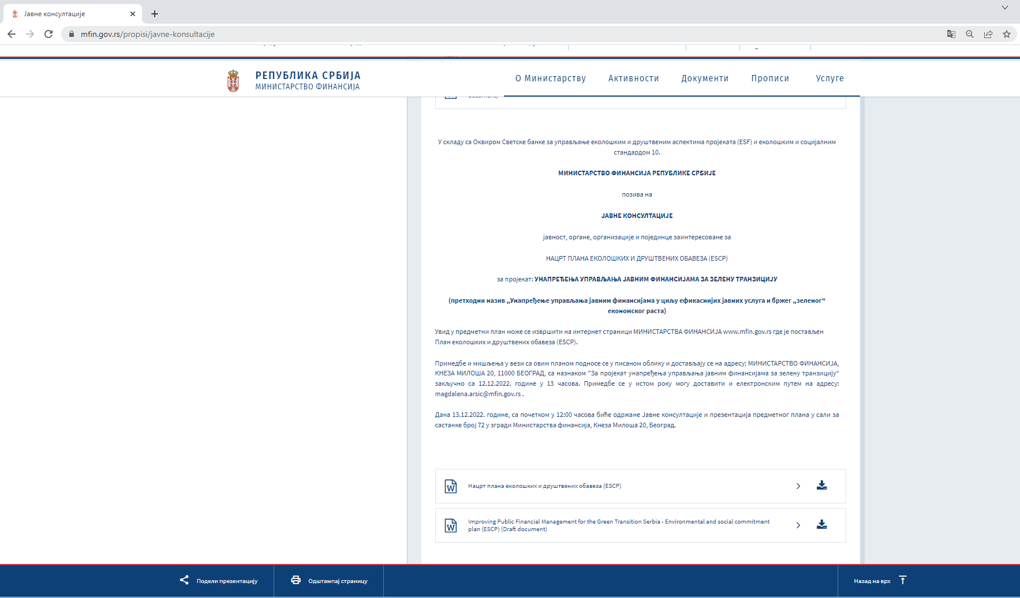

Picture 2: Public disclosure of public consultation on draft SEP and LMP, english and serbian versions, MoF website

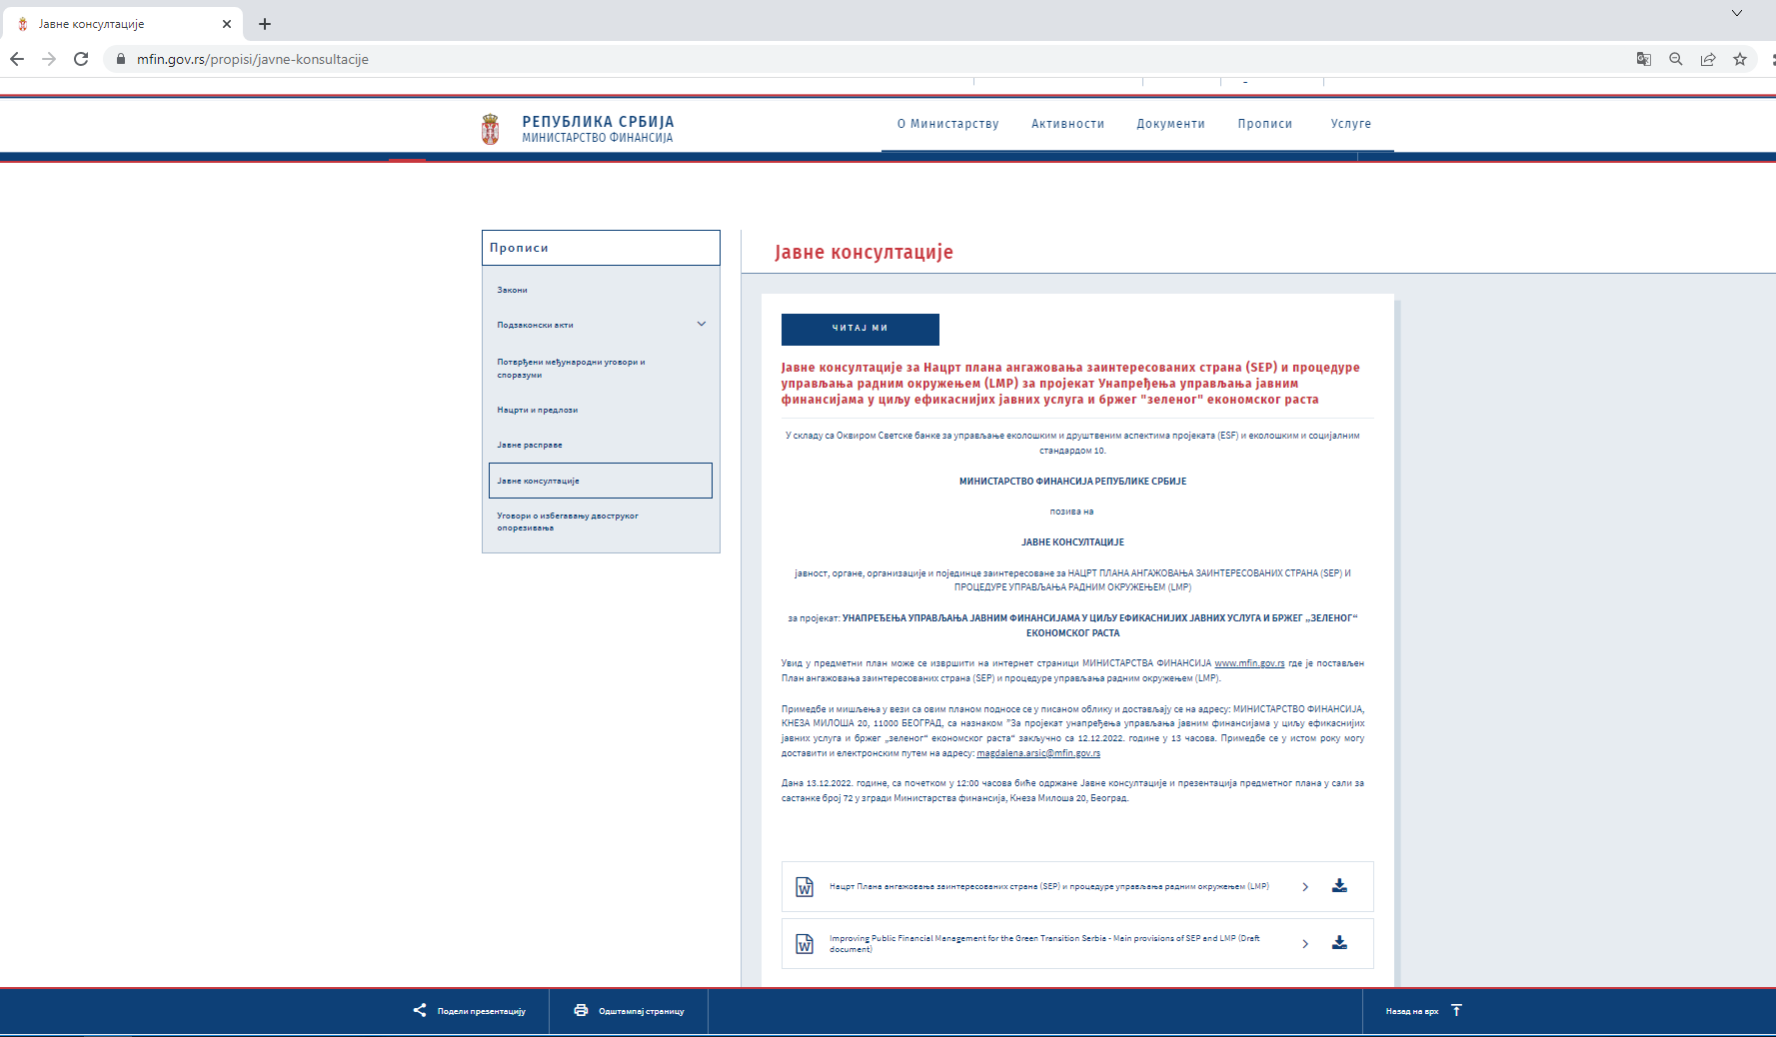

Picture 3: Announcement of public consultation in daily newspaper, on serbian language (“Politika”, December 1st 2022)

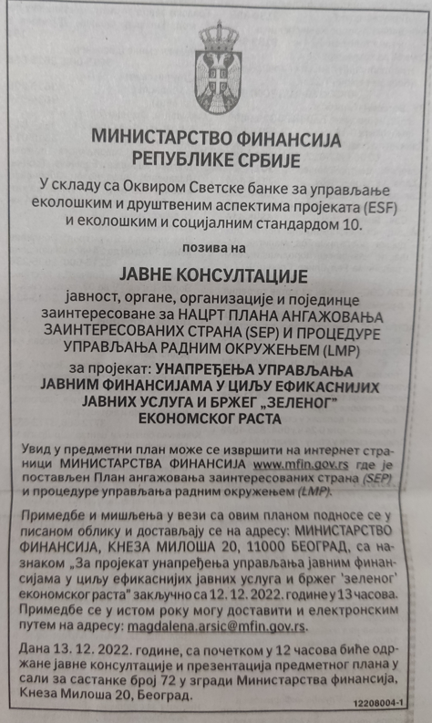

У складу са Оквиром Светске банке за управљање еколошким и друштвеним аспектима пројеката (ESF) и еколошким и социјалним стандардом 10.

МИНИСТРАТСВО ФИНАНСИЈА РЕПУБЛИКЕ СРБИЈЕ

позива на

ЈАВНЕ КОНСУЛТАЦИЈЕ

јавност, органе, организације и појединце заинтересоване за
НАЦРТ ПЛАНА ЕКОЛОШКИХ И ДРУШТВЕНИХ ОБАВЕЗА (ЕSCP)
за пројекат: УНАПРЕЂЕЊА УПРАВЉАЊА ЈАВНИМ ФИНАНСИЈАМА ЗА ЗЕЛЕНУ ТРАНЗИЦИЈУ

(претходни назив „Унапређење управљања јавним финансијама у циљу ефикаснијих јавних услуга и бржег „зеленог“ економског раста)

Увид у предметни план може се извршити на интернет страници МИНИСТАРСТВА ФИНАНСИЈА www.mfin.gov.rs где је постављен План еколошких и друштвених обавеза (ЕSCP).

Примедбе и мишљења у вези са овим планом подносе се у писаном облику и достављају се на адресу: МИНИСТАРСТВО ФИНАНСИЈА, КНЕЗА МИЛОША 20, 11000 БЕОГРАД, са назнаком ”За пројекат унапређења управљања јавним финансијама за зелену транзицију“ закључно са 12.12.2022. године у 13 часова. Примедбе се у истом року могу доставити и електронским путем на адресу: magdalena.arsic@mfin.gov.rs.

Дана 13.12.2022. године, са почетком у 12:00 часова биће одржане Јавне консултације и презентација предметног плана у сали за састанке број 72 у згради Министарства финансија, Кнеза Милоша 20, Београд.

У складу са Оквиром Светске банке за управљање еколошким и друштвеним аспектима пројеката (ESF) и еколошким и социјалним стандардом 10.

МИНИСТРАТСВО ФИНАНСИЈА РЕПУБЛИКЕ СРБИЈЕ

позива на

ЈАВНЕ КОНСУЛТАЦИЈЕ

јавност, органе, организације и појединце заинтересоване за
НАЦРТ ПЛАНА АНГАЖОВАЊА ЗАИНТЕРЕСОВАНИХ СТРАНА (SEP) И ПРОЦЕДУРЕ УПРАВЉАЊА РАДНИМ ОКРУЖЕЊЕМ (LMP)
за пројекат: УНАПРЕЂЕЊА УПРАВЉАЊА ЈАВНИМ ФИНАНСИЈАМА У ЦИЉУ ЕФИКАСНИЈИХ ЈАВНИХ УСЛУГА И БРЖЕГ „ЗЕЛЕНОГ“ ЕКОНОМСКОГ РАСТА

Увид у предметни план може се извршити на интернет страници МИНИСТАРСТВА ФИНАНСИЈА www.mfin.gov.rs где је постављен План ангажовања заинтересованих страна (SEP) и процедуре управљања радним окружењем (LMP).

Примедбе и мишљења у вези са овим планом подносе се у писаном облику и достављају се на адресу: МИНИСТАРСТВО ФИНАНСИЈА, КНЕЗА МИЛОША 20, 11000 БЕОГРАД, са назнаком ”За пројекат унапређења управљања јавним финансијама у циљу ефикаснијих јавних услуга и бржег „зеленог“ економског раста“. Примедбе се могу доставити и електронским путем на адресу: magdalena.arsic@mfin.gov.rs.

Дана 13.12.2022. године, са почетком у 12:00 часова биће одржане Јавне консултације и презентација предметног плана у сали за састанке број 72 у згради Министарства финансија, Кнеза Милоша 20, Београд.

