Improving Public Financial Management for the Green Transition Operation in Serbia
Main provisions of SEP and LMP
(Draft document)
This document is meant to represent the social risk management section of a broader Operation Implementation Manual (OIM) that will be further developed subject to the preparation of the overall OIM for the second component for Improving Public Financial Managemnt for the Green Transition Operation/ IPF component (hereinafter: "Project").i. OIM will provide basic guidelines for the implementation of the Operation, and in terms of social risk management, it will follow the provisions of this document.

The Operation Description and Social Risk Management

Improving Public Finance Management for the Green Transition in the Republic of Serbia is a four-year Operation supported by the World Bank, which aims to help the Government of the Republic of Serbia in strengthening its capacity to manage public finances and implement green investments. Key implementing institutions besides the Ministry of Finance are the Ministry of Environmental Protection, the Ministry of Construction, Transport and Infrastructure, the Public Policy Secretariat, the Republic Property Directorate, and the Public Procurement Office.

The Operation consists of two components:
1) Program for Results (PforR) component is comprising two results areas:
- Strengthen fiscal resilience, transparency, and spending effectiveness-focused on further strengthening fiscal resilience, using public expenditure management to enhance efficiency and a results focus, enhancing the ability to link plans and budgets through stronger costing at the planning stage, improving fiscal transparency, and improving the preparation of public investment projects.
- Green the expenditure cycle and monitor GHG emissions for Serbia’s green transition - focused on introducing and utilizing green criteria in PFM, PIM, and public procurement, and on strengthening systems for monitoring and reporting on GHG emissions from installations.
2) Investment Project Financing (IPF) component consisting of technical assistance to support the implementing entities in delivereing expected results. The IPF component will consist of TA - including trainings, capacity building and peer learning, support for stakeholder engagement, and support for managing the Program.
This Stakeholder Engagement Plan (SEP), and Labour Management Procedures developed by the Implementing Partner, pertain to both; the IPF and PforR component of the Operation.
The IPF component of the Improving Public Financial Management for the Green Transition Operation is assessed as having low risk while the PfoR component has moderate risk. Nonetheless, the Operation Coordination Unit (OCU) will appoint one part-time social /CE expert, and if needed environmental expert who shall ensure the implementation of the Project is in line with the provisions of the Environmental and Social Commitment Plan (ESCP) but also in line with the Environmental and Social Framework of the World Bank and applicable E&S standards.
Social Risk Management
As mentioned earlier, for the IPF component of the Оperation -Improving Public Financial Management for the Green Transition, the social risk is estimated to be low. The implementation of the IPF component will result in improved efficiency, fiscal transparency, better gender-informed budgeting and green investment reporting and will therefore benefit the broader community in Serbia. The main social issues to be addressed appropriately and timely during the Operation implementation relate to labor and working conditions (ensuring safe and adequate working conditions for workers who will be implementing TA under IPF component) and stakeholder engagement and information disclosure. The Project does not envisage any large-scale construction works. The proposed Operation will not produce any adverse impact on vulnerable groups and will not result in land acquisition or physical displacement.
For the efficient and effective implementation of the Operation activities, it is crucial to properly define and adequately implement the process of stakeholder and citizen engagement. Failure to do this carries a significant social risk that the Operation may not deliver entirely on its objective. Therefore, the Operation foresees continuous stakeholder engagement between citizens, the private sector, and the Government of the Republic of Serbia on the reforms being addressed, in line with the already established national practice and the Law on Planning System and other regulation in this area, as well as in line with provisions of the Strategy on cooperation with CSOs and other interested stakeholders.
Stakeholder engagement assumes engagement and communication between new and existing governmental stakeholders (affected parties), and stronger inclusion of other interested parties (private sector and citizens). A good exchange of information between the ministries and agencies that will implement the entire program is essential for its smooth implementation, while the application of a well-adjusted engagement strategy with citizens and the private sector will help improve fiscal transparency and will contribute to Opertaion sustainability.
The appropriate principles of the ESS10 are enshrined in the ESCP and will be operationalized in the activities to be performed on the ground.
Environmental and Social Provisions applicable to the Project
The Bank is committed to supporting Borrowers in the development and implementation of projects and programs that are environmentally and socially sustainable, and to enhancing the capacity of Borrowers' E&S frameworks to assess and manage the E&S risks and impacts of projects. To this end, the Bank has defined specific ESSs, which are designed to avoid, minimize, reduce or mitigate the adverse E&S risks and impacts of projects. The projects supported by the Bank must comply with the ESSs. Table 1. gives an overview of the ESSs and their applicability to this project.

Table13: ESSs relevant to the project
ESS |  | Applicable
ESS1 | Assessment and Management of Environmental and Social Risks and Impacts | Yes
ESS2 | Labor and Working Conditions | Yes
ESS3 | Resource Efficiency and Pollution Prevention and Management | No
ESS4 | Community Health and Safety | No
ESS5 | Land Acquisition, Restrictions on Land Use and Involuntary Resettlement | No
ESS6 | Biodiversity Conservation and Sustainable Management of Living Natural Resources | No
ESS7 | Indigenous People | No
ESS8 | Cultural Heritage | No
ESS9 | Financial Intermediaries | No
ESS10 | Stakeholder Engagement and Information Disclosure | Yes

These ESSs are accompanied by non-binding Guidelines, Best Practice Notes, Templates and Checklists (Please refer to the section on the World Bank Group Environmental, Health and Safety Guidelines).
The main provisions of ESS10 and ESS2 are described in more detail below.
Environmental and Social Standard 10 – Stakeholder Engagement and Information Disclosure
This standard recognizes the importance of open and transparent communication between the Borrower and project stakeholders as an essential element of good international practice. Stakeholder engagement can improve the environmental and social sustainability of projects, enhance project acceptance, and make a significant contribution to successful project design and implementation.
ESS10 objectives are the following:
- To establish a systematic approach in the engagement of project stakeholders that will help the Borrower not only to identify stakeholders but also to build and maintain a constructive relationship with them throughout project implementation.
- To assess the level of stakeholders’ influence and interest and ensure their support for the project.
- To take stakeholder’s views into account in project design and environmental and social performance.
- To promote and provide means for effective and inclusive engagement with project-affected parties throughout the project life cycle on issues that could potentially affect them.
- To ensure that adequate program information on environmental and social risks and impacts are disclosed to stakeholders in a timely, understandable, accessible and appropriate manner and format.
- To provide project-affected parties with accessible and inclusive means to raise any issues and grievances and allow Borrowers to respond to and manage such grievances.

Relevance to the Operation: Considering the nature of the activities to be implemented under the Operation strong stakeholder engagement for the proposed activities is the key to both, IPF and PfoR component success. The process of stakeholder engagement will be detailed in the OIM and will involve the following: i) Stakeholders’ identification and analysis; ii) Planning how the engagement with stakeholders will take place; iii) Disclosure of information; iv) Consultation with stakeholders; v) Addressing and responding to grievances, and vi) Reporting to stakeholders.
Concerning stakeholder identification and analysis, ESS-10 classifies project stakeholders into the following categories: a)Project-affected Parties ( PAPs) –individuals or groups that are affected or likely to be affected by the project); b) Disadvantaged/Vulnerable Groups or Individuals (project-affected parties which are more likely to be adversely affected by the project impacts and/or more limited than others in their ability to take advantage of a project’s benefits and, c) Other interested parties (OIPs)- other individuals or groups that may have an interest in the project. During the project preparation phase, the following stakeholders have been identified under each of these categories:

Table 2. Preliminary list of key stakeholders groups (Тo be further developed in the OIM)
Project Affected Parties | Other Interested parties | Disadvantaged or vulnerable groups
- Ministry of Finance  - Ministry of Environmental Protection  - Ministry of Construction, Transport and Infrastructure  - Ministry of Mining and Energy  - Ministry for Public Investments  - Public Policy Secretariat  - Public Procurement Office  - Public Property Office  - Serbian Environmental Protection Agency (SEPA) | - Citizens/general public  - Civil Society Organisations, and other relevant NGO’s  - National Convention on the EU  - Academia/ Policy Think Thanks  - Chambers of Commerce | - Staff members of implementing institutions with disabilities or language barriers  - Women staff members  - Citizens with disabilities  - Citizens living below the poverty line  - Roma  - Citizens with low literacy including low (ICT literacy)

A more detailed analysis of both stakeholder groups and engagement methods will be provided in OIM. Based on this classification, it will be ensured that the planning, implementation and monitoring of engagement activities are adequately coordinated among key stakeholders.
Given the nature of the overall Programme, the stakeholder engagement process is likely to be two-dimensional:
(I) Engagement and consultation of government stakeholders on what improvements are most critical, achievable, and in need of further effort; and
(ii) Engagement and consultation with the citizens, civil society and private sector to achieve better transparency in PFM and improve dialogue about green investments.
Stakeholder outreach and engagement modalities will be tailored to accommodate different needs of various stakeholder groups. The SEP will integrate a communication and awareness-raising plan which will be targeted to address all concerns and issues that could result from proposed activities relevant to the implementation of MRV system for GHG emissions. The part-time engaged Social/Environmental expert(s) will develop a communication and awareness-raising plan. Information flows (including data management and privacy) and policy commitments will be defined and will be regularly updated during the Operation. The existing practices and channels for discussion with interested stakeholders on PFM and green agenda topics will be the key element of the consultation process.
A central Grievance Mechanism (GM) will be established within the OCU to collect and manage all Operation related grievances. This will complement the existing GMs of participating government institutions. OCU will appoint a grievance focal point responsible for collecting grievances from different entry points, analyzing the data and monitoring any outstanding issues. This person will be instructed to report concerns related to the program activities to OCU and to keep and manage a central grievance log.
The MOF OCU will publicly disclose the information on how the complaints may be submitted and how they will be processed. This will include:
- a procedure to submit grievances through various channels such as comment/complaint forms, suggestion boxes, emails, and telephone hotline ;
- a procedure for addressing complaints including stipulated timeframes to respond to grievances.
The GM will be presented and explained in detail in the OIM.
In the case of any pandemic outbreak, during the Operation implementation, limitations to traditional stakeholder engagement activities may be imposed (i.e. exercise social distancing and avoid public gatherings) to prevent and reduce the risk of the virus transmission. In such circumstances, citizen engagement will be performed as per specifications listed in the World Bank’s Technical Note: Public Consultations and Stakeholder Engagement in WB-supported operations when there are constraints on conducting public meetings.
Environmental and Social Standard 2 – Labor and Working Conditions
This standard regulates working conditions, and the scope of its application depends on the type of employment relations between the Borrower and project workers. The term “project worker” is related to:
- people employed or engaged directly by the Borrower (including the project proponent and the project implementing agencies) to work specifically in relation to the project (direct workers);
- people employed or engaged through third parties to perform work related to core functions of the project, regardless of location (contracted workers);
- people employed or engaged by the Borrower’s primary suppliers (primary supply workers); and
- people employed or engaged in providing community labour (community workers).
ESS2 objectives are:
- To promote safety and health at work.
- To promote fair treatment, nondiscrimination and equal opportunity for project workers.
- To protect project workers, including vulnerable workers such as women, persons with disabilities and migrant workers, contracted workers, community workers and primary supply workers.
- To prevent the use of all forms of forced labor and child labor.
- To support the principles of freedom of association and collective bargaining of project workers in a manner consistent with national law.
- To provide project workers with accessible means to raise workplace concerns.
Relevance to the IPF component:
Given that the IPF component primarily focuses on TA for public financial management improvement no large-scale civil works are envisaged and therefore only negligible adverse impacts related to labor working conditions are expected. The applicable national legal framework is aligned with ILO conventions and principles of ESS2. Social/CE expert will provide support to the OCU in order to ensure that all labor-related activities are consistent with national legislation and ESS2, and ensure necessary information are available to Project workers and all sub-contractors engaged.
For the IPF component of the Operation, the project workers will include: (i) direct workers; workers employed as public administration officials directly engaged with the IPF Component, (ii) employees in consulting firms hired for different types of Technical Assistance (contracted workers).
As per ESS2, where government civil servants are working in connection with the project, whether full-time or part-time, they will remain subject to the terms and conditions of their existing public sector employment agreement or arrangement, in line with HR service of each Project Affected Parties. ESS2 will not apply to such government civil servants, except for the provisions of paragraphs 17 to 20 (Protecting the Work Force) and paragraphs 24 to 30 (Occupational Health and Safety). If the employment or engagement of a civil servant was transferred to the Project in accordance with all legal requirements, transferred workers will be subject to all requirements of the ESS2. The risks of sexual exploitation and abuse ( SEA) and sexual harassment (SH) in the workplace are estimated to be low, and will follow national legislation about SEA/SH. The Central GRM оф тхе Оператион will be SEA / SH-sensitized while signing a Code of Conduct for all project workers will be mandatory. Regarding working conditions, the applicable national legal framework is aligned with ILO conventions and the majority of the principles of ESS2. Nevertheless, all firms hired under the IPF Component will be contracted by the Government of Serbia and will be requested to provide documented evidence confirming their compliance with national labor law and ESS2. This requirement is emphasized in ESCP, bidding documents and the actual contracts between the OCU/MoF/GoS and its providers. Health and safety measures (including the provision of personal protective equipment, and emergency preparedness and response procedures ) for all workers will be ensured and adequate mitigation measures will be applied in line with the local legislation and the ESS2.
The OIM will further elaborate on the required provisions including the establishment of grievance mechanisms (GMs) for all project workers and other consultants to be engaged under IPF component.
MoF/OCU will develop and implement a grievance mechanism for direct workers to resolve workplace issues. The OCU will require contractors to develop and аctivate a grievance mechanism for their workforce, including subcontractors, before the commencement of works.
The workers' grievance mechanism will include:
- a procedure to submit grievances through various channels such as comment/complaint forms, suggestion boxes, emails, and telephone hotline ;
- a procedure for addressing complaints including stipulated timeframes to respond to grievances and to address cases.
- a register to record and track the timely resolution of submitted grievances.
- a responsible department/focal point to receive, record, address and track the resolution of grievances.
The workers' grievance mechanism will be described in staff induction training, which will be provided to all project workers.
Information about the presence of the grievance mechanism will be readily available to all project workers (direct and contracted) through notice boards, the presence of “suggestion/complaint boxes”, and other information channels as needed. The workers’ grievance mechanism will not prevent workers to use the conciliation procedure provided in the Labor Code or any other judicial mechanisms.
The content of the Code of Conduct is included in the World Bank Standard Bidding Documents and will include provisions relating to SEA/SH prevention. The OCU through engaged part-time Social/ Environmental/CE expert(s), other lead institutions included in the IPF component, and all contractors engaged, will implement a Code of Conduct. The Code of Conduct will reflect the company’s core values and overall working culture.
Reporting on the social performance of the Operation by the part-time Social CE expert, i.e. compliance with ESS2 and ESS10, will be conducted following the format and dynamics agreed with the World Bank.

ANNEX 1.

THE REPORT ON PUBLIC CONSULTATIONS ON THE DRAFT ENVIRONMENTAL AND SOCIAL COMMITMENT PLAN, STAKEHOLDER ENGAGEMENT PLAN AND LABOUR MANAGEMENT PROCEDURES

As required by WB Environmental and Social Standard 10 (ESS10) – Stakeholder Engagement and Information disclosure, during the preparation of the Draft Environmental and Social Commitment Plan (ESCP), Stakeholder Engagement Plan (SEP), and Labor management procedures (LMP), the Borrower carried out consultations with relevant stakeholders.
Starting on 28th November 2022, the Ministry of Finance (MoF) disclosed the draft ESCP, SEP, and LMP documents on its official website (Pictures 1 and 2) and announced invitations for Public Consultations for the public, bodies, and organizations interested in subject documents for the Project. The announcement was published in the daily newspaper “Politika” on 1st December 2022 (Picture 3). All interested parties were invited to participate in the Public consultation on draft ESCP, SEP, and LMP documents, by providing written comments and opinions via letters addressed to the Ministry of Finance or via email. All details are provided on the following link of the MoF: https://www.mfin.gov.rs/propisi/propisi-u-pripremi .
REPORT ON PUBLIC CONSULTATIONS, December 13, 2022
The MoF has started a public consultation and disclosure of the documents.
On December 13, 2022, at 12:00 AM (local time), public consultations and presentations of the draft ESCP, SEP, and LMP for interested parties and key stakeholders were held. The consultations were organized on the premises of the MoF, in conference room 72.
The World Bank IPF funded Improving Public Financial Management for the Green Transition (P175655) is assessed as having low risk. Draft ESCP, SEP, and LMP were developed to ensure the implementation of the Project in accordance with the World Bank standards related to environmental and social protection.
The meeting was attended by the relevant representatives of the MoF without other interested parties, having in mind the low risk of the Project and lack of interest to attend the consultation meeting. No written suggestions and recommendations were submitted to the MoF in the way and date specified in the invitation for Public consultations.
There were 8 attendees on public consultation, representatives MoF (4), MoF_Central Fiduciary Unit (2) and Consultants (2). The names and titles of the participants, due to protection of personal data requirements, will not be publicly disclosed.
The consultations were presented by: Ms. Verica Ignajtović, Assistant Minister, Department for International Cooperation and European Integration, MoF.
Questions and Answers:
During the public consultations, there were no questions, comments/remarks related to the presented draft SEP, LMP, and ESCP, bearing in mind that no other interest parties were present.
Public Consultation SummarySince there were no questions, comments, or suggestions, from the public, bodies, and organizations interested in subject documents for the Project, the final version of the SEP, LMP, and ESCP will be prepared according to the latest approved version by adding the report from the consultations after it gets approved by the WB team and the Borrower.
Picture 1: Public disclosure of public consultation on draft ESCP, english and serbian version, MoF website
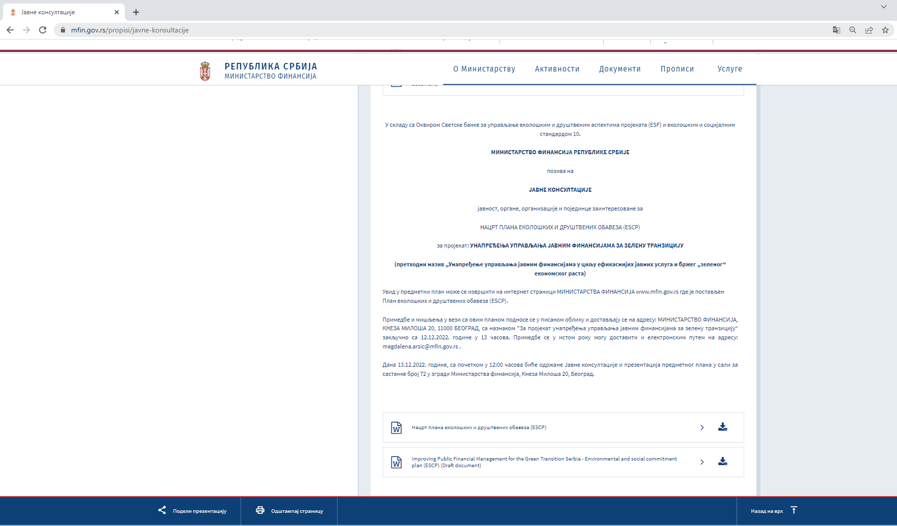

Picture 2: Public disclosure of public consultation on draft SEP and LMP, english and serbian versions, MoF website
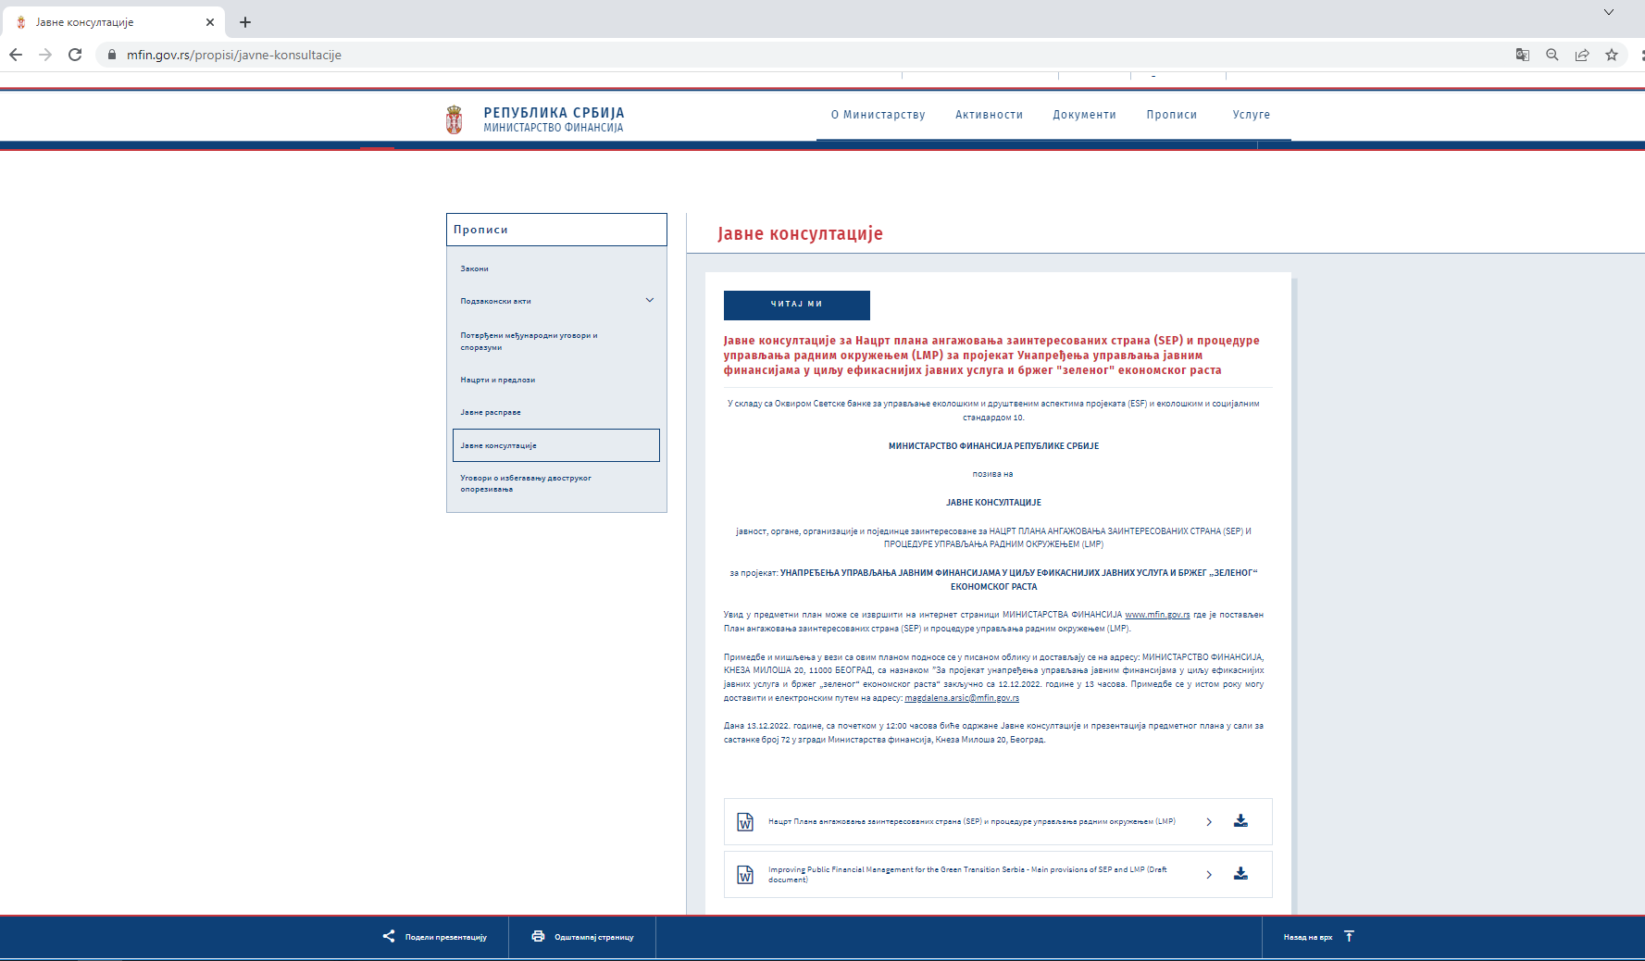

Picture 3: Announcement of public consultation in daily newspaper, on serbian language (“Politika”, December 1st 2022)

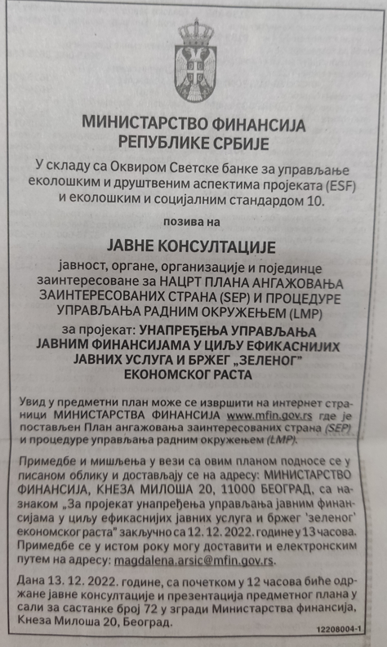

У складу са Оквиром Светске банке за управљање еколошким и друштвеним аспектима пројеката (ESF) и еколошким и социјалним стандардом 10.

МИНИСТРАТСВО ФИНАНСИЈА РЕПУБЛИКЕ СРБИЈЕ
позива на
ЈАВНЕ КОНСУЛТАЦИЈЕ
јавност, органе, организације и појединце заинтересоване за
НАЦРТ ПЛАНА ЕКОЛОШКИХ И ДРУШТВЕНИХ ОБАВЕЗА (ЕSCP)
за пројекат: УНАПРЕЂЕЊА УПРАВЉАЊА ЈАВНИМ ФИНАНСИЈАМА ЗА ЗЕЛЕНУ ТРАНЗИЦИЈУ
(претходни назив „Унапређење управљања јавним финансијама у циљу ефикаснијих јавних услуга и бржег „зеленог“ економског раста)
Увид у предметни план може се извршити на интернет страници МИНИСТАРСТВА ФИНАНСИЈА www.mfin.gov.rs где је постављен План еколошких и друштвених обавеза (ЕSCP).
Примедбе и мишљења у вези са овим планом подносе се у писаном облику и достављају се на адресу: МИНИСТАРСТВО ФИНАНСИЈА, КНЕЗА МИЛОША 20, 11000 БЕОГРАД, са назнаком ”За пројекат унапређења управљања јавним финансијама за зелену транзицију“ закључно са 12.12.2022. године у 13 часова. Примедбе се у истом року могу доставити и електронским путем на адресу: magdalena.arsic@mfin.gov.rs.

Дана 13.12.2022. године, са почетком у 12:00 часова биће одржане Јавне консултације и презентација предметног плана у сали за састанке број 72 у згради Министарства финансија, Кнеза Милоша 20, Београд.

У складу са Оквиром Светске банке за управљање еколошким и друштвеним аспектима пројеката (ESF) и еколошким и социјалним стандардом 10.

МИНИСТРАТСВО ФИНАНСИЈА РЕПУБЛИКЕ СРБИЈЕ

позива на

ЈАВНЕ КОНСУЛТАЦИЈЕ

јавност, органе, организације и појединце заинтересоване за
НАЦРТ ПЛАНА АНГАЖОВАЊА ЗАИНТЕРЕСОВАНИХ СТРАНА (SEP) И ПРОЦЕДУРЕ УПРАВЉАЊА РАДНИМ ОКРУЖЕЊЕМ (LMP)
за пројекат: УНАПРЕЂЕЊА УПРАВЉАЊА ЈАВНИМ ФИНАНСИЈАМА У ЦИЉУ ЕФИКАСНИЈИХ ЈАВНИХ УСЛУГА И БРЖЕГ „ЗЕЛЕНОГ“ ЕКОНОМСКОГ РАСТА

Увид у предметни план може се извршити на интернет страници МИНИСТАРСТВА ФИНАНСИЈА www.mfin.gov.rs где је постављен План ангажовања заинтересованих страна (SEP) и процедуре управљања радним окружењем (LMP).

Примедбе и мишљења у вези са овим планом подносе се у писаном облику и достављају се на адресу: МИНИСТАРСТВО ФИНАНСИЈА, КНЕЗА МИЛОША 20, 11000 БЕОГРАД, са назнаком ”За пројекат унапређења управљања јавним финансијама у циљу ефикаснијих јавних услуга и бржег „зеленог“ економског раста“. Примедбе се могу доставити и електронским путем на адресу: magdalena.arsic@mfin.gov.rs.

Дана 13.12.2022. године, са почетком у 12:00 часова биће одржане Јавне консултације и презентација предметног плана у сали за састанке број 72 у згради Министарства финансија, Кнеза Милоша 20, Београд.

Available in English at: http://www.worldbank.org/en/projects-operations/environmental-and-social-framework/brief/environmental-and-social-framework-resources#guidancenotes
In order to ensure compliance with ESS10 throughout the Project's lifecycle, the OIM will be amended to reflect adequate provisions and principles that will guide the preparation and implementation of the IPF Component actions..
In order to ensure compliance with the ESS2 the OIM will be further developed to include adequate provisions and proportionate mitigation measures which will be based on the findings of due diligence on existing labor and working conditions related systems and procedures. Furthermore, The OIM will also be amended to provide guidance on requirements to be incorporated in terms of reference, contracts, and reporting mechanisms to ensure that the activities and outputs are in line with ESS2.

