Republic of Serbia
Ministry of Finance
Kneza Milosa 20
11000 Belgrade

Labor Management Procedures
for
Catalyzing Long Term Finance Through Capital Markets (P176069)

Final

January 2022

Contents
1. INTRODUCTION 4
1.1 Project Background 4
1.2 LMP Background and Outline 4
2. SCOPE OF APPLICATION 5
3. RESPONSIBILITIES FOR MANAGEMENT OF LABOR 5
4. OVERVIEW OF LABOR USE ON THE PROJECT 6
5. ASSESSMENT OF KEY POTENTIAL LABOR RISKS 7
6. BRIEF OVERVIEW OF LABOR LEGISLATION: TERMS AND CONDITIONS 8
7. BRIEF OVERVIEW OF LABOR LEGISLATION: OCCUPATIONAL HEALTH AND SAFETY (OHS) 13
8. RESPONSIBLE STAFF 16
9. POLICIES AND PROCEDURES 17
10. AGE OF EMPLOYMENT 19
11. TERMS AND CONDITIONS 20
12. GRIEVANCE MECHANISM 21
13. THIRD PARTY MANAGEMENT 23
14. PRIMARY SUPPLIERS 23
ANNEX 01 LABOR AND WORKING CONDITIONS COMPLIANCE REPORT (to be used by third parties engaging contracted workers) 24
ANNEX 02 THIRD PARTIES STATEMENT ON COMITMENT tO COMPLY WITH PROVISIONS OF LABOR LEGISLATION and THE PROJECT`S LMP 27
ANNEX 03 REPORT ON PUBLIC CONSULTATIONS 28

ABBREVIATIONS
BELEX | Belgrade Stock Exchange
CFU | Central Fiduciary Unit
E&S | Environmental and Social
ESCP | Environmental and Social Commitment Plan
ESF | Environmental and Social Framework
ESS | Environmental and Social Standards
GBV | Gender Based Violence
GIIP | Good International and Industry Practices
GM | Grievance Mechanism
GoS | Government of Serbia
LHSW | Law on Health and Safety at Work
LL | Labor Law
LMP | Labor Management Procedures
MoF | Ministry of Finance
NGO | Non-Governmental organization
OG | Official Gazette
OHS | Occupational Health and Safety
OIP | Other Interested Parties
PIU | Project Implementation Unit
PPE | Personal Protective Equipment
RS | Republic of Serbia
SEA | Sexual Exploitation and Abuse
SEP | Stakeholder Engagement Plan
SH | Sexual Harassment
SSC | Serbian Securities Commission
SMS | Safety Management System
TA | Technical Assistance
UN | United Nations
WB | World Bank
WBG EHS | World Bank Group Environmental, Health and Safety guidelines

INTRODUCTION

1.1 Project Background
The Government of the Republic of Serbia (GoS) has requested support from the World Bank (Hereinafter: The Bank) to improve the enabling environment for capital markets development and deepen the corporate bond market, including through green and/or sustainable issuances. These are also the project’s overall objective.
The ultimate leadership will be with the MoF, and oversight of the project will be in the hands of the Ministry of Finance`s (MoF) Capital Markets policy and regulatory unit, while the governance of the Project is also expected to include a Task Force with the MoF, Serbian Securities Commission (SSC) and BELEX represented, in order to improve the coordination of (and commitment to) all project components. The Project will also support establishment of the One Stop Shop for capital markets housed within MoF, with the objective to raise awareness regarding the need to develop green and climate financing in Serbia.

1.2 LMP Background and Outline
Operations and activities for which the World Bank`s Investment Project Financing (IPF) is sought after October 1,2018, fall under the application of the Environmental and Social Framework (ESF). The ESF comprises, inter alia, the Environmental and Social Standards, which set out mandatory requirements for the Borrower and the Project.
In response to the requirements for the Project to comply with the ESF, The MoF has adopted these Labor Management Procedures (LMP), laying out the approach to meeting the objectives of ESS 2: Labor and Working Conditions (ESS2) on the Project.
The document identifies the categories of workers who are expected to be hired/engaged under the Project, sets out the terms and conditions for employment or engagement of workers on the Project, specifies the requirements and standards to be met and the policies and procedures to be followed, assesses risks and proposes the mechanisms for compliance measures implementation. The LMP is developed to help avoid, mitigate and manage risks and impacts in relation to project workers and set out the way in which project workers will be managed, in accordance with the requirements of the national law supplemented by measures to close any gaps to meet the requirements of ESS2.
This LMP consists of 14 chapters. Chapter 1 serves as introduction and provides background on and where the procedures originated from. Chapter 2 defines the scope of application of this LMP. The labor governance structure is presented in Chapter 3. An overview of labor use in the project is presented in Chapter 4. Key potential labor risks are listed in Chapter 5. The national labor regulatory framework governing employment relationship in Serbia is discussed in chapter 6. Occupational health and safety in country legal requirements are dealt with in Chapter 7. Working conditions, management of employee relationships and protection of work force are addressed in Chapters 8, 9,10 and 11, the grievance mechanism in Chapter 12 and third parties’ management and primary supply workers in the last two chapters.
In the light of the unfolding COVID-19 crisis, pandemic impact considerations are included as a crosscutting element among the majority of labor issues and are addressed in the LMP under each relevant chapter.

SCOPE OF APPLICATION
This LMP applies to all Project workers hired under the Project as defined by ESS2.
In the context of this Project the term “Project worker” refers to:
- people employed or engaged directly by the MoF to work specifically in relation to the project (direct workers). Direct workers are expected to be staff and consultants engaged by the MoF including Project Implemention Unit (PIU) staff and consultants, and personnel engaged for the establishement and operating of the One Stop Shop, which will be established and housed within the MoF.
- people employed or engaged through third parties (‘Third parties’ may include contractors, subcontractors, brokers, agents or intermediaries) to perform work related to core functions of the project, regardless of location (contracted workers). Contracted workers are expected to be employees of firms and service providers engaged in providing technical assistance, trainings, capacity buidling, legal and financial advisory services to beneficiary corporates for the bond issuance program; and for the establishmenet of One Stop Shop at MoF.
The LMP applies to project workers including fulltime, part-time, temporary, seasonal and migrant workers.
For any civil servants of the MoF who may be engaged in carrying out project activities, the terms and conditions of their public sector employment will continue to apply. ESS2 provisions on OHS, as well as prohibition of child and forced labor, will apply to civil servants.
Employees of beneficiary corporates are not considered project workers under ESS2 definition. They shall remain subject to the national labor and OHS requirements.
The category of primary suppliers are not relevant within the scope of this Project.
Community workers will not be engaged as the nature of the project does not require engagement of the community labor.
Serbia is signatory to the International Labor Organization (ILO) and United Nations (UN) Conventions informing the ESS2. Serbia has ratified more than 70 ILO Conventions including the 8 Core Conventions. The Serbian legal framework guiding Labor and Working Conditions, including OHS, is, except for a few minor gaps fully aligned with the standards set out in ESS2. Where the national legal framework falls short in compliance, measures to bridging the gaps will be implemented as outlined below.

RESPONSIBILITIES FOR MANAGEMENT OF LABOR
For direct workers hired or to be hired by the MoF and Central Fiduciary Unit (CFU) management responsibilities lies within these entities. The provisions of the LMP will be communicated within the institution and copies both on English and Serbian made available. The Head of the PIU will be responsible for selection, engagement and management of the PIU staff while the employee relations/HR issues of civil servants employed by the MoF being temporarily seconded to the PIU will be dealt with in line with the Ministry’s human resources (HR) policies and by their Personnel / HR Department, while these relations for staff engaged in the CFU is subject to the Labor Law (as they are not civil servants but consultants engaged through consultancy contracts) with labor management responsibilities distributed among the Head of CFU and HR Department of the MoF. The management of OHS is within the remit of the OHS Officer within MoF, CFU (person appointed in compliance with the Law on Safety and Health at Work ). Any third party hiring contracted workers shall be responsible to manage employee relations/HR issues in line with this LMP and national labor and OHS laws. The requirements will be embedded into the bidding documents through which this LMP will become contractually binding for any third-party providing goods and services to the Project. The Bidding documents shall include a written Commitment Statement (please refer to Annex 02) that in case contract is awarded, the LMP shall be implemented and a Monitoring template to be used for monitoring of labor management performance ( please refer to Annex 01). As for the implementation of these Labor Management Procedures, unless a Labor and Employee Relations/HR Manager or OHS Specialist is assigned to the project by the third party, the team leader/authorized representative will be responsible for compliance with the LMP provisions.

OVERVIEW OF LABOR USE ON THE PROJECT
The following categories of Project workers, are expected to be engaged:
Direct workers. Direct workers will include independent consultants hired specifically to work in relation to the project. These will include:
- Staff of the Project Implementation Unit (PIU), housed by the Ministry of Finance.
- External consultants to be integrated into the PIU,
- External consultants and advisors hired by the Capital markets policy and regulatory unit in the Ministry of Finance to temporarily increase the capacity of the unit,
- Qualified, skilled consultants to be hired by the Serbia Securities Commission (SSC) to execute new responsibilities focused on the new one-stop shop establishment of which is supported by the Project.

The Central Fiduciary Unit (CFU) of the MoF will perform fiduciary responsibilities i.e. procurement and financial management. The CFU was established within the MoF in 2017, with the aim to provide fiduciary support to all World Bank supported projects in Serbia. The CFU is adequately staffed with knowledgeable and experienced consultants but will subsequently express their needs as to the number and profile of the potential personnel who will be assigned to the project work if needed. Their employment/engagement contract will incorporate the terms and conditions consistent with LMP and the labor law as they are not civil servants.

These workers will be engaged through the standard form of Contracts for Consultancy services provided by The Bank and whose application is covered under the Loan Agreement to be signed between the Republic of Serbia and the Bank.

Labor and working conditions of civil servants who are or will be working in connection with the project in the PIU remain subject to the national civil servants legislation. Their employment relationship will remain subject to the terms and conditions of their existing public sector employment agreements or arrangements with the exception of requirements in the area of protecting the workforce and Occupational Health and Safety (OHS) and prohibition of child and forced labor shall apply to civil servants engaged in the project. Until and unless a legal transfer (compliant to legal requirements) of their employment or engagement is made such that they are direct project workers, during the life of the Project, their status remains unchanged as civil servants.
The number of direct workers is estimated between 15-20, to be engaged for management, technical, social, environmental, financial, procurement, and administrative functions within the PIU. Direct workers will be experienced, national and internationally recruited professionals in their respective fields, with high education prevalently and various educational backgrounds (e.g., lawyers, bankers, financial experts, economists, environmental and social science and similar). They will be hired under individual contracts, with different time inputs (full-time or part-time), and will be assigned specific tasks and responsibilities as their services process essential for the core functions of the project.
The MoF currently has a , and additional capacity will be built upon by identifying new positions to cover the specific needs of this Project and the extended scope of the environmental and social requirements brought by the Environmental and Social Framework (ESF) of the World Bank.
Contracted workers: Contracted workers will be engaged or employed by third parties such consultants providing restructuring assistance based on the corporate governance review, consultants for financial restructuring or corporate restructuring, capital market training for directors and management of corporates etc. technical assistance for the development of specific products, such as green/ thematic bonds, municipal bonds, and other products in line with the strategy, and comprehensive suite of technical, financial, and advisory services. Sub-contractors to the extent that such sub-contracting is permitted under the parent contracts are subjected to this LMP alike. These imply professionals and support staff assigned by the Consultants, or by any Sub-Contractor or Sub-Consultants, to perform the Services or any part thereof.

In its contractual and legal relationship with any third party, the MoF will have the role of the employer as assigned under the respective contracts. Contract awards will follow World Bank standard procurement procedures (incorporating standards wording for labor and working conditions requirements which to which these LMP shall be appended to, alternatively excerpts from this LMP may be used). Third party engagement shall be subject to a competitive open tendering procedure.

Migrant Workers: Foreign citizens employed in accordance with the law regulating employment of foreign citizens in Serbia enjoy the same rights in terms of work, employment and self-employment as Serbian citizens provided that the conditions set in the law are fulfilled. In other words, if any foreign citizen obeys the law and obtains a temporary or permanent residence and a work permit or personal work permit, he/she is entitled to receive the same treatment as any other employee in Serbia. As potential contracted workers are to be selected on the basis of their competences and professional achievement whether they are migrant or non-migrant workers is deemed irrelevant. For that reason, the LMP will not specifically address migrant workers as migrant workers are not expected under the scope of this Project.

Primary supply workers: Given the nature of the project, primary supply workers, as defined in EES2, shall not be engaged on the project
Community workers: Given the nature of the project, community workers, as defined in EES2, shall not be engaged on the project

ASSESSMENT OF KEY POTENTIAL LABOR RISKS
Key Labor Risks
Key labor risks are associated with office work (office-based activities). Project workers (external consultants and civil servants, and employees of service providers) are anticipated to be office staff with most of their work done indoors. These educated knowledge workers will have desktop jobs, although direct workers may carry out minor off-site travel may be needed to supervise project beneficiaries direct workers, and contracted workers may be required to travel to to conduct training/TA (. Service providers engaged to provide TA are anticipated to be reputable firms with regulated employment conditions for workers. Thus, labor risks both in terms of working conditions and occupational health and safety are minor and negligible for all project. Off-site travel (i.e., visit to beneficiaries, training events) might expose them to travel and site related risks and requires some caution, but in terms of occupational health and safety these risks are minimal. Due preparations will have to be made for each visit or event focusing on traffic safety and provision of adequate gear or equipment. Given the nature of the project work and the expected profile of project workers, the risk of child or forced labor tends to be nil. None of the identified project workers are considered vulnerable. No other labor risks are considered to be significant.

The office work related risks can be mitigated or reduced through improved organization of work processes and regular HR policies.

National legislation requires each employer to assess labor risks specific to each job/position. The recognized risks have to be addressed in compliance with the OHS legislation. OHS officers with each employer are responsible to ensure that adequate prevention and protection measures are in place and that safety regulations are obeyed. With the use of protection equipment, proper training and organization of site, the risk of work-related injuries and occupational health can be significantly reduced.

The Project is assessed as Low on gender-based violence including sexual exploitation and abuse (SEA) and sexual harassment (SH). . Mitigation measures to address SEA/SH risks are included in the section on Policies and Procedures. The risk factors assessment considered the institutional capacity of the implementing agency, low volume labour influx, no pre–existing social conflict and tensions, strong local law enforcement which resulted in the conclusion that this is a low labor risk project and risks can be managed through the requirements of this LMP.

COVID-19 continued risk considerations: All categories of workers may be involved in activities that raise COVID-19 exposure concerns, as most activities include physical contact between the workers and/or physical interactions with other people. To mitigate the risk, the project will overall follow applicable national guidance and WHO guidelines. The identification of the risks will assist designing appropriate mitigation measures to address those risks, such as, rearranging work tasks or reducing number of workers in the offices/workplaces to allow physical distancing, providing appropriate forms of personal protective equipment (PPE) and putting in place alternatives to direct contact – like teleworking or remote work and video conferences wherever possible.

BRIEF OVERVIEW OF LABOR LEGISLATION: TERMS AND CONDITIONS
This section sets out the key aspects of national labor legislation with regards to terms and conditions of work, and how national legislation applies to different categories of workers identified in Section 3. The overview focuses on legislation which relates to the items set out in ESS2, paragraph 11 (i.e. wages, deductions and benefits).
Various laws, policies and code of practices are applicable to the implementation of this LMP. These laws and policies are aligned with the international standards, namely ILO Conventions and EU Directives, as the terms, conditions and instruments proposed in the international conventions and directives are incorporated into the national labor legislation.
The Constitution of the Republic of Serbia (2006) guarantees the right to work, free choice of occupation, availability of work positions under equal conditions, respect of person’s dignity at work, safe and healthy working conditions, necessary protection at work, limited working hours, daily and weekly interval for rest, paid annual holiday, fair remuneration for work done and legal protection in case of termination of working relations.
The Labor Law (LL) (passed in 2005 as amended in 2018) is the main legislation that guides labor practices in Serbia. The terms and conditions provided by this Law includes ban to direct or indirect discrimination regarding employment conditions and choice of candidates for performing a specific job, conditions of labor and all the rights deriving from the employment relationship, education, vocational training and specialization, job promotion and cancelling an employment contract for reasons of sex, birth, language, race, color of the skin, age, pregnancy, health condition, and/or disability, ethnic origin, religion, marital status, family obligations, sexual orientation, political or other belief, social background, financial status, membership in political organizations, trade unions, or any other personal characteristic.
The LL also envisages engagement via Service Contracts (Ugovor o Delu). Direct workers engaged on the Project as individual consultants will be contracted under consultancy contracts, which are treated as Service Contracts under the LL. Although the LL applies to all employees who work in the territory of Serbia, civil servants are also subject to terms and conditions of a set of laws and bylaws specifying different categories of civil servants, their duties, restrains imposed, selection process, performance management, promotion, professional development, apprenticeship, disciplinary measures, grievances and complaints, HR planning and administration. Employment relationship is also regulated by the Law on Employment and Unemployment Insurance (2019, 2010, 2015, 2017) and the Law on Employment of Foreign Citizens (2014, 2017, 2018, 2019). The rights stemming from the employment relationship are further elaborated by the Law on Mandatory Social Security Insurance Contribution (2004, 2005, 2006, 2009, 2011, 2012, 2013, 2014, 2015, 2016, 2017, 2018, 20019), the Law on Retirement and Disability Insurance (2003, 2004,2005, 2006, 2009, 2010, 2012, 2013, 2014, 2018, 2019) and the Law on Health Insurance (2019). These laws specify contributions, benefits and entitlements covering all employees and extending the entitlement to social security, retirement, disability, injury and health insurance to those who work without the established working relationship. The following laws specifically address the issues of discrimination, harassment and equal opportunities at work: Law on the Prohibition of Discrimination (2009), Law on the Prevention of Harassment at the Workplace (2010), Rulebook on Conduct of Employers and Employees in Relation to Prevention and Protection from Harassment at Work (2010), Law on Protection of Whistle Blowers (2014), Law on Gender Equality (2009). They lay out the grievance mechanisms and legal procedures in relation to perceived maltreatment and infringement of the employee’s right.
The above legislation applies to all who work or provide services in Serbia, patriates or expatriates workers or employers. Although it is mostly congruent with the ESS 2 requirements, certain gaps do exist. Wherever such gaps appear, the LMP provide guidelines to be followed in order to ensure compliance with the ESS2 on the condition that such guidelines do not infringe any local regulations.
Provision of information and forms of employment contracts
The employment relationship is established by an employment contract concluded between an employee and an employer. The contract is executed in at least three copies, one of which is handed to the employee (LL - Article 30).
An employment contract may be concluded either for an indefinite (open-ended) or definite (fixed-term) period of time (LL - Article 31). The contract is concluded in writing before the employee starts to work.
Should an employer fail to conclude the employment contract with an employee, it is deemed that the employee has established the employment relationship for an indefinite period, as of the day he started working (LL - Article 32).
An employment contracts constituting elements are: the name and address of the employer, name and address of the employee, employee’s qualifications, position and job description, place of work, type of employment relationship (open-ended or fixed term), duration of the fixed term contract and grounds for establishing employment relation for a definite period of time, date of commencement of work, working hours (full time, part time, reduced time in case of extremely physically demanding or health hazard work), the base salary on the date of contract signing, elements for determining the base salary and work performance, salary compensation, allowances to salary and other earnings of the employee, deadlines for payment of salaries and other earnings to which the employee is entitled, and duration of daily and weekly working hours. (LL- Article 33).
If employment contracts are agreed for a fixed -term one or more consecutive employment contracts may be concluded for a period that with or without interruptions must not exceeding 24 months. There are exceptions however to this rule e.g. replacement of a temporarily absent employee - until his/her return; employment of a foreign citizen – up to the expiry of the work permit; work with a newly established employer – up to 36 months, employment of an unemployed person who lacks up to five years to fulfill of one of the preconditions for retirement. (LL- Article 37)
Temporary and seasonal work, service supply contract and supplementary work are forms of work without established employment relationship. The persons hired in this manner do not enjoy the rights of employees. However, a contract or agreement between the two parties may provide for some rights typically arising from the employment relationship. Temporary and seasonal work have a maximum limitation to 120 days per year. The contract is made in writing, with an unemployed person, a part time employee to the prescribed full time or a pensioner. (LL Article 197)
Wages and deductions
An employee is entitled to an appropriate salary determined in conformity with the law, bylaw and employment contract.
Employees are guaranteed an equal salary for the same work or the work of the equal value. The work of the equal value is the work which requires the same level of qualifications, i.e. education, knowledge and skill, and which implies the same responsibilities and results in an equal contribution to the employer’s business success. (LL Article 104). The timing of payment of wages and remunerations is stipulated in the employment contract.
The law prohibits any deductions apart from those imposed by court or consented by the employee and specifies insurance contributions paid from the gross salary. The employer calculates and pays the contributions together with salaries/wages.
An employee is entitled to a minimum salary for standard performance and the time spent at work. The minimum salary is determined on the basis of the minimum wage rate, the time spent at work and the taxes and contributions paid from the salary. A bylaw or the employment contract stipulates the reasons for rendering a decision on paying the minimum salary. (LL Article 111)
The minimum wage rate is determined by a decision of the Social and Economic Council of the Republic of Serbia and is determined per a working hour without taxes and contributions, for the calendar year, not later than 15 September of the current year, and is applicable from 1 January next year. (LL Article 112)
Working hours
Full-time working hours amount to 40 hours a week. A bylaw may institute shorter full-time working hours than 40 hours a week, but not shorter than 36 hours a week. (LL - Article 51)
The Employer may reschedule working hours in order to support business activities, ensure the effective use of working time and the execution of specific work within the deadlines. Nevertheless, the total working hours of an employee in the period of six months during the course of a calendar year must not exceed in average the contracted working hours of the employee.
In any case of rescheduling of the working hours, the employee must not work longer than 60 hours a week. The rescheduling of working hours is not considered overtime work (LL Article 57 and 58).
Overtime
Overtime is limited to eight hours a week. Employees are not to work longer than 12 hours a day, including the overtime. (LL Article 53)
Rest period
Any employee is entitled to: (i) rest in the course of a working day with a minimum duration of 30 minutes. The rest period is calculated into working hours. (LL Article 64) (ii) rest between two working days of minimum of 12 consecutive hours within 24 hours. In the rescheduled working hours scheme, the rest cannot be shorter than 11 consecutive hours within 24 hours. (LL Article 66); (iii) weekly rest for a minimum of 24 consecutive hours plus 12 hours (within 24 hours). The weekly rest is normally on Sunday. However, an employer may determine another day for using the weekly rest, should the nature or organization of work so require. The weekly rest of an employee who, because of working in different shifts or in rescheduled working hours, is unable to use the rest as specified above, cannot last less than 24 consecutive hours. If it is indispensable that an employee works on the day of his weekly rest, the employer must allow him/her to take a rest of at least 24 consecutive hours in course of the subsequent week. (LL Article 67).
Annual leave
Employees are entitled to annual leave. The right to annual leave in a calendar year is granted after a month of continuous employment from the day the employment relationship with the employer has become effective. Continuous employment’ also includes periods of temporary inability for work, pursuant to health-care regulations, and any absence from work with compensation of salary. Neither waiver by the employee nor denial of this right by the employer is allowed even against substitution with pecuniary compensation, except in case of termination of the employment relationship. (LL Article 68). For each calendar year a minimum of 20 work days is set, which can be increased based on performance results, working conditions, work experience, qualifications and other criteria defined in the employment contractor bylaws (LL Article 69). The employer decides about the time of use of annual leave, with prior consultation with the employee. (LL Article 75). In the termination events unused days of annual leave are pecuniary compensated, in the amount of the average salary in the previous 12 months, proportionate to the number of unused annual leave days. (LL Article 76).
Employees are entitled to paid leave in an aggregate duration of five workdays in course of a calendar year, in events such as conceiving marriage, spouse's childbirth, serious illness of a member of immediate family, and in other cases determined by a bylaw or employment contract. Additional five workdays are allowed due to death of an immediate family member and two consecutive days for every instance of voluntary blood donation, counting also the day of donating blood. Members of the immediate family include a spouse, children, brothers, sisters, parents, adoptive parent, adoptee and a legal guardian. The bylaw and the employment contract may provide for longer paid leaves and a wider circle of persons. (LL Article 77).

Maternity leave
Any employed woman is entitled to absence from work due to pregnancy and child birth (maternity leave), as well as to a leave for nursing a child, in the total duration of 365 days. The maternity leave commences, on the ground of the opinion of a competent health agency, 45 days at the earliest, but imperatively 28 days prior to the time set for childbirth. The maternity expires with the third month after the childbirth. After the expiry of maternity leave, child nurse leave commences, which expires after 365 days from the commencement day of the maternity leave. The father of a child may as well exercise the right to parental leave lasting three months in cases the mother abandons the child, dies, or is prevented due to other justified reasons to exercise that right (serving a prison term, serious illness and the like) and child nursing leave. During maternity leave and leave for nursing a child, compensation of salary is paid in conformity with the law. (LL Article 94)
Written Notice and payments on termination
Prior to termination of an employment contract in the case of violation of work duties or non-compliance with work discipline, the Employer must warn the employee in writing of the existence of a cause for cancelling the employment contract and to leave him a period of not less than eight days from the day of serving the warning to take a stand on the allegations stated in the warning. An employment contract is cancelled by a decree in writing and is served on the employee in person, in employer's premises, or employee's permanent or temporary residence. Employment relationship of the employee ceases as of the day of serving of the decree, unless another time limit is determined by the decree. (LL Article 185). In cases of termination, other than in retrenchment cases, the employer pays to the employee all unpaid salary, compensation of salary and other earnings due on the day of termination of the employment relationship on or before 30 days, after termination of employment relationship. (LL Article 186). In cases of retrenchment all payment due are to be paid prior to termination date.

The employer may terminate the employment contract of an underperforming employee or an employee who does not have the necessary knowledge and skills to perform his duties, or impose some of the measures foreseen for violation of work duties or non-compliance with work discipline, if he has previously given a written notice regarding the deficiencies in employee’s work, provided guidance and stated appropriate deadline for the employee to enhance work performance, but the employee fails to improve his/her performance within the given deadline. (LL Article 180a)
The employee may terminate the employment contract with a prior written notice of 15 calendar days (notice period). A bylaw or employment contract may determine a longer notice period, but not longer than 30 days. (LL Article 178)
Labor disputes
The Law on Peaceful Settlement of Labor Disputes (2014 as amended in 2018) regulates the method and procedures of settlement of collective and individual labor disputes. A dispute can be initiated on a voluntary basis in relation to the collective agreement, strike, termination of employment contract, working hours, annual leave, disbursement of salary, compensation of costs, discrimination and abuse at work, etc. The labor and employment legislation does not foresee grievance mechanisms as mandatory practice, but provides for judicial protection of employees in case of unfair or unlawful employment relationship practices instead. However, the legislation relating to prevention of discrimination, sexual harassment and abuse at work and combating corruption is much more specific, laying out clear procedures to be followed in any case of discriminatory actions, unjust treatment or concerns over non-compliance with the law.
Minimum age of employment
The minimum employment age is 15 years. Persons under the age of 18 can enter into an employment agreement with the consent of their legal representative or custodian, given it does not harm them in any way and does not hold minors from acquisition of education. Full working hours of an employee younger than 18 years of age may neither be determined in duration longer than 35 hours a week, nor longer than eight hours a day. (LL Article 87). Overtime work and rescheduling of working hours of an employee under the age of 18 is prohibited.
Forced labor
The Constitution prohibits forced labor. In addition, Serbia ratified the ILO Forced Labor Convention and the Abolition of Forced Labor Convention both of them currently in force. The Criminal Code of Serbia lists different categories of trafficking as criminal offences and sets punishment ranging from a minimum of 10 years of imprisonment depending on specifics and circumstances of the offence in particular if it involves underaged persons.
In summary, there are only a few areas where national legislation is either partially aligned with ESS2, or the implementation modality is not well defined. There are no clear requirements regarding consultation with employees on OHS matters and the legislation fails to institute OHS review and evaluation mechanisms and limits to keeping records instead.
Covid-19 considerations: In order to minimize exposure to COVID-19, employers of both direct and contracted workers may use the instruments provided for in the LL. The LL foresees performing activities outside the employer's premises (i.e. remote work and work from home) while guaranteeing the employee the same terms and conditions of employment (namely base salary, working hours, rests and leaves). The employment contract has to specify the manner of supervision, work equipment to be used and possible compensation if the employee uses their own equipment. In exceptional circumstances (such as pandemic), the authorities suggest issuing a decision allowing employees to work from home as well as rescheduling working hours and working in shifts.
The following issues are identified as a gap with ESS2: Labor and Working Conditions requirements
The labor legislation pertinent to categories of project workers is directly applicable. Employers are not required to prepare labor management procedures but key elements can be found in collective bargaining agreements (norm) and employer specific employment rulebooks (in absence of bargaining agreements). The labor and employment legislation does not foresee grievance mechanisms as mandatory practice, but provides for judicial protection of employees in case of unfair or unlawful employment relationship practices instead. For employees qualified as civil servants the law guiding their employment addresses the grievance mechanism in such a way to provide for employment relations and workplace dispute resolution through the Appeals Commission housed within the institution providing employment. The LMP effectively addresses the gap for GM. The law allows that termination payments and other statutory benefits are paid to the workers within 30 days for termination, while the ESS2 requires these payments to be made before the termination of employment.

BRIEF OVERVIEW OF LABOR LEGISLATION: OCCUPATIONAL HEALTH AND SAFETY (OHS)
This section sets out the key aspects of the national labor legislation with regards to occupational health and safety, and how national legislation applies to the different categories of workers identified in Section 1. The overview focuses on legislation which relates to the items set out in ESS2, paragraphs 24 to 30
The Constitution of Serbia establishes a fundamental right to safe working conditions (2006). The Law on Safety and Health at Work (LSHW, 2005, 2015, 2017) is the key legislative act in this area defines general principles of basic requirements and preventive measures that are related to occupational health and safety (OHS) at the workplace, the existing and anticipated risks, prevention of accidents and occupational diseases, training, informing, and consulting of the employees, and their equal engagement in the occupational health and safety protection issues.
The LSHW is applicable to all domestic and foreign employers regardless of their size and to all domestic and foreign employees regardless of their employment status. The law has transposed the ratified ILO Conventions and the EU Directives and complies with WB ESS2 to a large extent. Wherever certain gaps between the Serbian legislation and ESS2 appear, the gap filling measures provided in this LMP shall apply.
Responsibilities of the Employer
The Law stipulates the obligations and responsibilities of the employer in relation to ensuring safety and health at work (general obligations, special obligations and training for employees) and assessing and mitigating labor-related risks and hazards, provides for appointment of persons (licensed OHS officers or legal entities) responsible for ensuring labor compliance and creating a safe working environment, and determines preventive measures for ensuring occupational safety and health. It also regulates the rights and obligations of employees, the way of organizing the task of occupational safety and health, provision of the first aid at the workplace, the possibility of selecting representatives among the employees for occupational safety and health, obligations of the employer related to keeping records, information exchange and cooperation with relevant institutions, the issue of the professional exam and licensing, the competence of the Occupational Safety and Health Administration. The provisions of the LSHW are further elaborated in numerous by-laws, for the purpose of regulating the specific implementation procedures.
Reporting on accidents, fatalities, injuries
The employer is responsible to record accidents, instances of professional diseases and dangerous accidents and provides the report to the employee and the social security service. During the first 24 hours from the accident, the employer should notify the relevant authorities law enforcement bodies (police) and Labor Inspectorate in case of fatal, mass or individual serious injury, due to which the employee is unable to work for three consecutive working days, as well as any dangerous event that may put health and safety of the employees at risk. The employer also has the responsibility to keep a log of accidents and occupational diseases at workplaces.
Provision of workers’ insurance in instances of injuries, fatalities disability and disease
Insurance. An employee is entitled to compensation of salary for the time of absence from work due to temporary inability to work lasting up to 30 days in the amount of 100% of the average salary in the 12 preceding months before the month in which temporary inability occurred, on condition that it may not be lower than the minimum salary, if the temporary inability was caused by an injury sustained at work or by occupational disease. (LL Article 115). Remedies take into account wage level while the court may consider other socio-economic features. An employer is obliged to pay to an employee compensation for damage sustained due to an injury at work or occupational disease as determined by the court or the insurance company.

Preventive and protective measures
The Rulebook on identification and assessment of workplace and working environment risks (RIAWWER) (article 8 and 9) distinguishes between identification and assessment of threats and hazards. It classifies threats into: mechanical, electrical and workplace related. Hazards are classified into: (a) occurring during work processes ( e.g. chemical, physical, biological, indoor and outdoor climate, illumination, radiation, hazardous materials, etc.), (b) physical and psychological stress and strain attributable to work performed, (c) work schedule and organization of work processes (e.g. long working hours, shifts, night work etc.) and (d) other hazards such as third party workplace violence, work with animals, high or low atmosphere pressure work in or under water surface etc. the framework for modification, substitution, or elimination of hazardous conditions or substances based on workplace risk assessment and results thereof.

OHS risks which may be specific to female workers. A female employee in course of pregnancy and a female employee who is breastfeeding a child may not work at jobs that may be harmful to her health or her child’s health. She may not work overtime or night shift. (LL Article 89 and 90)
Right and responsibility to report unsafe situation, right to leave the workplace and prohibition of retaliation for reporting
An employee is obliged to notify the employer of every kind of potential danger that could affect the safety and health at work. (LL Article 80) and has the right to refuse to perform task of instruction in contradiction with the law, or which due to breach of occupational safety and health regulations may trigger risk for employees. Employees are entitled to leave the workplace in the event of danger.
Collaboration and consultations with project workers on OHS
OHS representatives and OHS boards and provides for employees and their representative to give suggestions and information, initiate measures and demand inspection, there is no clear requirements regarding consultation with employees on OHS matters. In the event that employees of several workplaces work together, each employer involved in this work process is to cooperate with other employers with regards to compliance with occupational health and safety regulations as well as hygiene norms. The employers should also ensure the coordination of their activities according to the specifics of the work, with regards to the occupational health and safety risk prevention. Employers should also exchange and share relevant information regarding health and safety and professional risks. And finally, it should be ensured that employees and representatives of employees are duly informed of relevant issues.
Facilities for workers
The law is silent on accommodation requirements. The provision of accommodation for employees is seen to be outside the scope of OHS legislation. However, some elements can be found in collective agreements and the Rulebook on Preventive Measures for Healthy and Safe Work at Workplace (“Official Gazette of RS” no. 21/2009 and 1/2019) – List of health and safety measures at the workplace.
System for regular OHS review
Under a general requirement set out by Labor Safety Law, the employer has an obligation to ensure health and safety at workplace. As part of this obligation, employer needs to abide by the requirements set out by the law, make sure that employees’ health and safety is not exposed to risks of negative impact. The law requires the employer to regularly carry out control of safety condition of technical equipment as well as maintenance and cleaning of the individual protection gear, proper use and if needed timely replacement of it. In addition, the employer should be carrying out measurement and evaluation of such factors in the work environment. The law requires employers to document occupational hazards and report on accidents.
While the LHSW addresses the main ESS2 requirements related to occupational health and safety, the coverage of certain requirements is partial. The law is applicable to all economic sectors, although specific needs of specific workplaces, activities and industries are addressed separately. The law does not require employers to engage in consultation concerning OHS. Provision of appropriate facilities and accommodation is considered outside the scope of OHS and is only partially addressed in OHS related legislation.
COVID-19 considerations: The Ministry of Labor, Employment, Veterans and Social Affairs (MLEVSA) has recently issued the Rulebook on Preventive Measures for Safe and Healthy Work and Control and Prevention of Epidemic. The Rulebook specifies the obligations of both employers and employees and lists the activities that must be carried out to prevent epidemic from spreading and ensure safe and healthy work environment. In addition, employers must prepare the plan for implementation of measures for prevention and control of epidemic, which has to be part of the act of assessment of the risks at workplaces. An example of this plan can be downloaded from the site of the MLEVSA. This LMP reinforces the commitment of all the participants in the Project to comply with prescribed obligations and implement all the required measures.

RESPONSIBLE STAFF
The PIU housed under MoF, will be responsible for the following:
- Implement this labor management procedure to direct workers
- Maintain records of recruitment and employment process of direct workers
- Monitor employment process of contracted workers to ensure it is carried out in accordance with this labor management procedure and national labor law
- Ensure that the grievance mechanism for project workers is established, monitor and report on its implementation

The Head of PIU will be responsible for managing direct workers and overseeing the implementation of the LMP in the following areas:

- Ensure implementation of these Labor Management Procedures with third parties.
- Monitor and verify that Third Parties meet labor and OHS obligations toward contracted workers (including workers engaged by their subcontractors),
- Monitor third parties’ implementation and compliance with the LMP.
- Monitor compliance with occupational health and safety standards at all workplaces in line with Serbian occupational health and safety legislation.
- Ensure that the grievance redress mechanism for project workers is established and implemented and that workers are informed of its purpose and how to use it.
- Introduce a system for regular monitoring and reporting on labor and occupational safety and health performance.
- Monitor implementation of the Project Worker Code of Conduct and Gender Based Violence (GBV) Code of Conduct.
- Ensure Bidding documents are supplemented with binding principles for application of the LMP. This will include provisions that non-compliance with the national legislation, particularly the legislation regarding terms and conditions of employment, labor rights and occupational health and safety, may constitute the ground for termination of the contract with a contracted party and exclusion of that party from the project.

POLICIES AND PROCEDURES
The MoF HR policies are defined by the LL, Law on Civil Servants, Law on OHS and the Collective Agreement for civil servants (negotiated at 3 years terms, current agreement validity is until 2021 when terms will be re-negotiated). There is HR Management Service at the Government level, for civil servants, performing specialist tasks related to HR management in ministries, special organizations, services of the Government and support services of administrative districts (planning, recruitment and selection, administration of central HR registry, planning and provision of training and development. The labor, working conditions and OHS requirements as defined in the MoF HR policies are in line with standards as set forth in ESS2 and this LMP. The policies adopted for the project will contribute to the achievement of ESS2 objectives and are in line with the MoF HR Policies. All Employers of direct or contracted workers, in the project must ensure safety and health at work. Strict adherence to the legal provisions, notably the LHSW, is required. It is the responsibility of the MoF and third parties as Employers (both civil servants and consultants regardless of their employment status) to fulfill all the obligations stipulated by the law. This includes assessment of the OHS risks and hazards, informing and training of project workers on the occupational health and safety issues, and taking preventive measures prior and during the work process in order to mitigate or diminish risks for project workers’ health and safety.
The third party should adapt work processes, work stations and work environment in such a manner to make them safe and hazard free. If any protective equipment is needed, MoF and the third party will provide project workers with it at the third party’s expense. The third party must keep records prescribed by the national legislation regarding health and safety at work, and duly report work-related injuries, near misses, fatalities and diseases, in compliance with the law. As for the risks relating to transportation and traffic and residual risks of the workplace, the third party will take reasonable precautionary measures as part of normal work routine. The project promotes fair treatment, non-discrimination and equal opportunity of project workers. Any and every Employer to direct or contracted workers, will ensure that the selection process for project workers is bias-free, and that the requirements set are not directly or indirectly discriminatory. The project workers will be recruited and assessed on the basis of their competence and professional achievements. Gender, birth, language, race, colour of the skin, age, pregnancy, health condition, and/or disablement, ethnic origin, religion, marital status, family obligations, sexual orientation, political or other belief, social background, financial status, membership in political organisations, trade unions, or any other personal characteristic unrelated to inherent job requirements cannot be ground for making any decision regarding employment and the employment relationship. However, third parties are encouraged to take a gender sensitive approach and make reasonable accommodation to make it possible for persons with disabilities to take part in the project. Provided that project workers are expected to be established experts, no person under the age of 18 years will be employed or engaged for work on the project. All project workers will perform work or provide services under conditions set in their engagement/employment contract or agreement in return for remuneration. Their status must be clearly defined in line with the national law. Any form of disguised employment will not be acceptable. For short term and part time workers, the agreement on work should foresee the possibility of providing some rights typical of the employment relationship (refund of travel expenses, leaves, etc.). All project workers are entitled to fair treatment and protection from harassment and sexual harassment and abuse at work. The contracted party must install mechanisms that will protect the project worker from incidence of mistreatment. If it happens anyway, the grievance mechanism should be in place to enable the project worker to file grievances to a competent person within the company/institution and be informed on the actions taken subsequently in relation to his grievances, without prejudice to his/her right to seek judicial protection. If a third party does not have an affective grievance mechanism in place, they must follow the guidelines in section 9 to design and install such mechanism. Whether adequate GM is in place shall be confirmed by signing the Statement of compliance with provisions of labor legislation (Annexed to this LMP in Annex 02 to be appended to the Contract). In no way any project worker will be prevented from joining a trade union or any other worker organization. The principle of free association and collective bargaining will be strictly respected. The third party must not condition the participation of a project worker in the project, his/her status, remuneration or entitlements on the project worker’s membership or activity in any organization. Adherence to law and good practice and a high level of integrity is expected from all participants in the project. Any tender documentation will include provisions that non-compliance with the national legislation as supplemented by this LMP, particularly the legislation regarding terms and conditions of employment, labor rights and occupational health and safety, may constitute the ground for termination of the contract with a contracted party and exclusion of that party from the project
As specified in the Labor Law of Serbia, the employment of project workers will be based on the principles of non-discrimination and equal opportunity. There will be no discrimination with respect to any aspects of the employment relationship, such as recruitment, compensation, working conditions and terms of employment, access to training, promotion or termination of employment. The following measures will be developed by third parties and monitored by the PIU to ensure fair treatment of all employees:

- Ensure that the selection process for project workers is bias-free, and that the requirements set are not directly or indirectly discriminatory. The project workers will be recruited and assessed based on their competence and professional achievements. Gender, birth, language, race, color of the skin, age, pregnancy, health condition, and/or disablement, ethnic origin, religion, marital status, family obligations, sexual orientation, political or other belief, social background, financial status, membership in political organizations, trade unions, or any other personal characteristic unrelated to inherent job requirements cannot be ground for making any decision regarding employment and the employment relationship.
- However, third parties are encouraged to take a gender sensitive approach and make reasonable accommodation to make it possible for persons with disabilities to take part in the project.
- Applications for employment will be considered in accordance with the application procedures established by the contractors.
- Clear job descriptions will be provided in advance of recruitment and will explain the skills required for each post.
- All workers will have written contracts describing terms and conditions of work and will have the contents explained to them. Workers will sign the employment contract. Terms and conditions of employment will be available at work sites.
- The contracted workers will not pay any hiring fees. If any hiring fees are to be incurred, these will be paid by the Employer (‘Contractor’).
- Depending on origin of the employer and employee the contracts will be developed in corresponding language understandable for both parties.
- In addition to written documentation, an oral explanation of conditions and terms of employment will be provided to workers who may have difficulties with understanding the documentation.
- While communication language related problems are not expected, attention should be given to ensuring coordination between different contractors and means to address any language differences.
- Foreign workers will require residence permit, which will allow them to work in Serbia
- PIU will include in contracts that all personnel must be of the age of 18 years or more and procedures to verify the aged
The PIU will include into the bidding documents specific OHS standard requirements that all third parties will meet under this project. The standards will be consistent with local regulations, WBG EHS guidelines and GIIP (Good International and Industry Practices). The following OHS standard requirements should as a minimum:
- Risk Assessment Procedure;
- Emergency response procedure;
- OHS training;
- Refuse to work policy.
- COVID -19 Induction training and PPE.
The PIU will inform the Bank within 48 hours about any incident or accident related to the project which has, or is likely to have a significant adverse effect on the environment, the affected communities, the public or workers (labor, health and safety, or security incident, accident or circumstance), but no later than three calendar days after the occurrence of the event. Such events can include strikes or other labor protests, serious worker injuries or fatalities, project-caused injuries to community members or property damage. The PIU will prepare a report on the event and the corrective action and submit to the Bank within 30 calendar days of the event.
Third Parties will be required to provide the periodic information on the performance in terms of labor, occupational health and safety issues. In addition, they shall report to the PIU about any inspections and audits carried out by the respective ministries – Labor, Health and Social Affairs of Serbia. The findings of the labor inspections will be presented to the PIU and the Bank at request.
Third Parties shall use the recommended Format for Report on Compliance with Conditions of Work with ESS2, provided in Annex 1 of the LMP, to prepare reports on labor & OHS issues.

COVID-19 Considerations: The COVID-19 crisis is putting pressure on employers and workers, whether they have to implement new procedures and practices in a very short time, or to suspend their work and business activities. Overall, the project will follow relevant national guidance’s and WHO guidelines. Some general measures may help employers and workers to stay safe and healthy and ensure operation of business.
- Appropriate preventive measures that will contribute to suppressing transmission of COVID-19 must be immediately implemented by employers and employees alike in compliance with the instructions of the public authority. All relevant information and instructions have to be available to all workers. Workers and worker representatives should be involved in assessment of risks in work environment and conceiving control measures.
- Place of business operating during the Coronavirus (Covid-19) pandemic need to ensure they are protecting their workforce and minimizing the risk of spread of infection. If an activity cannot be undertaken safely, it should not take place.
- In case of a high rate of absence, work should be adapted to cope with a reduced number of workers. Putting in place new methods and procedures and changing roles and responsibilities should be considered.

AGE OF EMPLOYMENT
The minimum age of employment in the Project will be 18 years.
Serbia has adopted ILO conventions on child labor and incorporated them in the legal system. The minimum age of employment in Serbia is 15 years. An employment relationship may be established with a person under 18 years of age with the consent, in writing, of a parent, adopting parent or guardian, provided that such work does not put at risk his/her health, morality and education, i.e. provided that such work is not prohibited by law. The contractors will be required to verify the identify the age of all workers. This will require workers to provide official documentation to verify age such as a national identification card, passport, driver’s license, birth certificate, valid medical or school records. A person under 18 years of age must present a medical certificate attesting that he/she is capable of performing the activities related to the specific job, and that such activities do not harm his/her health.
If a child under the minimum age is discovered working on the project, measures will be taken to immediately terminate the employment or engagement of the child in a responsible manner, taking into account the best interest of the child.
As third parties are expected to employ or engage highly qualified, experienced and competent project workers ( with extensive prior experience and professional background), no one under the age of 18 will be employed or engaged under the Project. If any third party employs or engages a person under the age of 18 years, this will be reported to the authorities (Labor Inspectorate) and measures taken against the party in accordance with the conditions of contract.
No other restrictions regarding the age of employment will be imposed. The age of workers will not be used as a criterion in deciding on hiring and promoting project workers or terminating their contracts.

TERMS AND CONDITIONS
The terms and conditions of employment in Serbia are governed by the provisions of the LL, while occupational health and safety is guided by the Law on Health and Safety at Work (LHSW).
A project worker may be employed or engaged for work on the project only after negotiating, signing, and receiving a copy of an employment contract or engagement agreement that contains information required by the provisions of the LL.
The project worker can be employed on a permanent (open-ended contract) or temporary (fixed-term contract) basis, or can be engaged without establishing the employment relationship on the basis of an agreement. In either case, the project worker will be registered in the Central Registry of Compulsory Social Insurance, in accordance with the national legislation of the Republic of Serbia. If the project worker is employed / engaged in his/her domicile country other than Serbia, he/she will be registered in accordance with the national legislation of that country. In case of self-employed project workers, the evidence of registration in the Central Registry of Compulsory Social Insurance or a corresponding foreign body has to be presented.
The terms and conditions of employment or engagement of the project worker must meet the inter alia the following standards:
- The project worker should in advance be clear about the job he/she is going to do and the wage/salary/fee he/she is going to receive.
- The project worker will be paid on a regular basis, at least once a month, or, if so agreed, upon the completion of specific activities, in accordance with the employment contract or engagement agreement.
- The project worker will work eight or fewer hours a day, with payment of overtime.
- Any work longer than eight hours is considered overtime work and the project worker should receive extra payment for the hours of overtime work. In any case, the project worker cannot work more than 12 hours a day.
- The project worker is entitled to a daily rest of at least 11 hours within 24 hours.
- The project worker is entitled to a weekly rest of at least 24 consecutive hours.
- Average weekly hours of work in a six-month period cannot exceed 40 hours.
- The project worker is entitled to annual, sick, maternity and family leave in line with the Serbian Law. Where the national legislation does not stipulate entitlement to leaves on any ground (i.e. temporary or seasonal work), the contracted party will provide the project worker, at his/her request, with a reasonable period of leave taking into consideration all the circumstances.
- An employment contract or engagement agreement, except in case of permanent employment, ends on the date of its expiry, unless both parties have agreed otherwise. In case of an early termination, a written notice will be submitted at least 15 days in advance. The termination of employment contract and payment of any related entitlements will be done in compliance with the national legislation. As per ESS2 requirement, statutory payments including severance payments, unused annual leave, social and pension contributions shall be paid before or on the date of employment termination.
- Risk related to specific jobs will be assessed. In conformity with the national legislation (LHSW), any third party engaging or employing contracted workers will be responsible for taking preventive and protective measures to ensure a safe and healthy work environment and informing the project worker on all the relevant issues and conditions affecting his/her health and safety at work. The project worker will respect regulations relating to safety and protection of life and health at work in order not to put in danger his life and health or life and health of others.
COVID-19 Considerations: The project will overall follow relevant national guidance, WHO guidelines to address risks of COVID-19 exposure for project workers. All employers of project workers have the overall responsibility of ensuring that all practicable preventive and protective measures are taken to minimize occupational risks. Employers are responsible for providing, where necessary and so far, as is reasonably practicable, adequate protective clothing and protective equipment, at no cost to the worker. Employers are responsible for providing adequate information and appropriate training on occupational safety and health, consulting workers on OSH aspects associated with their work and providing measures to deal with emergencies.
Workers have a right to remove themselves from danger when they have good reason to believe that there is an imminent and serious danger to their safety or health, and the duty to inform their supervisors immediately.

- The Project shall establish mechanisms that will prevent discrimination, harassment, sexual harassment and abuse at work and ensure equal treatment and equal opportunity for all. The service providers working in Serbia should follow the procedure laid out by the national legislation regulating the area of discrimination, harassment and equal opportunity.
- Project workers have the right to form or join union or other organizations of their choosing and to bargain collectively, in accordance with the national legislation. The employer (third party) will not interfere with the worker’s right to choose the organization or opt for an alternative mechanism to protect their rights regarding working conditions and terms of employment.
- The project worker will be able to raise his/her grievances using the grievance mechanism defined in section 12.

GRIEVANCE MECHANISM
The LL provides for judicial protection of employees in case of unfair or unlawful employment relationship. Any employee may refer to trade union or other representative labor organization for help in handling any disciplinary or grievance action. The Employer should not prevent any project worker from seeking assistance or advice in such situations. The Law on Peaceful Settlement of Labor Disputes allows for settlement of both individual and collective grievances and claims arising from the employment relationship and work situations without referring to judiciary through mediation of mediators and arbiters and agreement of the parties involved. On the contrary, the Serbian legislation relating to prevention of discrimination, sexual harassment and abuse at work and combating corruption is much more specific and is aligned with the above stated requests laying out clear procedures to be followed in any case of discriminatory actions, unjust treatment or concerns over non-compliance with the law.
The above stated mechanisms provided by the Serbian legislation are considered as minimum standard to be achieved in addressing labor dissatisfaction and perceived maltreatment. In addition labor grievance mechanisms shall be adopted by the Project as mandatory practice.
The PIU will develop and implement a grievance mechanism for direct workers to address workplace concerns.

PIU will require third parties to develop and implement a grievance mechanism for their workforce, prior to commencing the activities they have contracted for.
The workers grievance mechanism will include:
- a procedure to receive grievances such as comment/complaint form, suggestion boxes, email, a telephone hotline;
- stipulated timeframes to respond to grievances and to address cases;
- a register to record and track the timely resolution of grievances;
- a responsible department to receive, record, address and track resolution of grievances.
The workers grievance mechanism will be described in staff induction trainings, which will be provided to all workers. The mechanism will be based on the following principles:
- The process will be transparent and allow workers to express their concerns and file grievances.
- There will be no discrimination against those who express grievances and any grievances will be treated confidentially.
- Anonymous grievances will be treated equally as other grievances, whose origin is known.
- Management will treat grievances seriously and take timely and appropriate action in response.
Information about the existence of the grievance mechanism will be readily available to all project workers (direct and contracted alike) upon their employment or engagement. The information should be made available together with the notification on prohibition of harassment and protection of whistle blowers.The Project workers’ grievance mechanism will not prevent workers to use conciliation procedure provided in the Labor Code or any other judicial mechanisms.
The project worker is entitled to give suggestions, remarks and information regarding health and safety at work. He/she may refuse to work if his/her life or safety is endangered or if appropriate measures for provision of health and safety at work are not in place. The project worker may express his/her concern or raise grievances to the appointed OHS officer or through the workers’ representative in the Health and Safety Council if such exists in the company.
Staff induction training for all project workers will be conducted to include detailed information on the grievance mechanism. The training should make it clear that the process will be transparent and will allow workers to express their concerns and file grievances, that there will be no discrimination against those who express grievances, that any grievances, anonymous or not, will be treated confidentially and equally, that the management will treat grievances seriously and take timely and appropriate action in response and that grievance mechanism does not prevent workers to use conciliation or judicial procedures, as provided by law.

Contracted parties are required to implement these mechanisms, even if such requirement is not prescribed by any law of the domicile country, in case contracted parties are foreign companies.

THIRD PARTY MANAGEMENT
The Project will use the Bank’s Standard Procurement Documents for solicitations and contracts, and these include labor and occupational, health and safety requirements.

The implementation of the LMP begins with the tender procedure. The PIU will ensure that these incorporate standardized social clauses in the tender documentation and contract documents, in order for potential bidders to be aware of the requirements to be met. The tender documents shall also state that adherence to the national legislation regarding labor and employment relations and occupational health and safety is a prerequisite for participation in the project. Tender documents shall be clear that forced labor, child work or disguised employment are unacceptable and may be the ground for exclusion from the project. The requirements should also include ban to discrimination, harassment and gender-based violence. The bidders will be required to submit a statement confirming their awareness of WB ESF standards, their firm compliance with the national labor and employment and occupational health and safety laws and labor management procedures in accordance with WB ESS2, their willingness WB ESS2, their willingness to establish a GM if not established or to use the project GM, to refrain to refrain from any practice that can be interpreted or perceived as discriminatory or unfair to their employees and in breach of ESS2 requirements. The statement template is presented in Annex 02. The statement should be signed by the bidder’s legal representative. The failure to submit such statement will exclude a bidder from taking part in bidding. The PIU will make reasonable efforts to ensure that the third parties awarded with the contract are reliable law-abiding entities who do not have history of disrespect for labor law, unresolved labor disputes or frequent work-related accidents. During the evaluation the reliability of the third party’s Due diligence shall be exercised.

PRIMARY SUPPLIERS
Primary Suppliers are not anticipated under the project.

ANNEX 01 LABOR AND WORKING CONDITIONS COMPLIANCE REPORT (to be used by third parties engaging contracted workers)

Assignment name:
Contract ref. No:
Contract period: Start date (M/D/Y) End date (M/D/Y)
Service Supplier:
Reported period:
Date of report:
Signature of authorized person:

LABOR AND WORKING CONDITIONS COMPLIANCE REPORT

I/ COMPANY EMPLOYEES* STATISTICS:
- Total number of employee’s gender disaggregated1: M______F_______

- Number of employees with an employment contract

- Number of persons engaged without established employment relationship

- Number of employees with access to social security, pension and health insurance

- Number of employees/engaged persons who receives wages/salaries regularly at least once a month

- Number of employees who left the company in the reported period

- Number of employees hired in the reported period

- Number of hours worked per employee (monthly average)

- Total overtime (monthly average per employee)

- Number of injuries at work (in reporting period and cumulative since contract start)

- Number of fatalities at work (in reporting period and cumulative)

- Number of reported violence

- Number of reported harassment/ abuses

- Availability of an accessible and functioning employee grievance mechanism (Y/N)

- Number of grievances raised with the GM (in reporting period and cumulative since contract start)

- Number of grievances resolved by GM (in reporting period and cumulative since contract start)
- Number of suits filed with regard to labor, employment and OHS issues

- Number of disputes brought to peaceful settlement/ voluntary arbitration procedure

- Number of visits by labor/ OHS inspection

*The employee is any natural person employed or engaged to work or perform service for the employer
1 The number of employees refers to the actual number/headcount on the date of the report.

II/ PROJECT WORKERS STATISTICS:
- Total number of project workers:

- Number of project workers with an employment contract:

- Number of project workers with other types of contract:

- Number of project workers with access to social security, pension and health insurance verified by confirmation from the registry:

Working and Labor Conditions Screening Check List
 | Terms and conditions | Yes / No | Notes
1 | All project workers have an employment contract or engagement agreement in writing. | Yes ¨  No ¨ | If “No” please specify and explain
2 | All project workers are paid at least once a month | Yes ¨  No ¨ | If “No” please specify and explain
3 | All project workers worked 8 hours a day, 40 hours a week, or less | Yes ¨  No ¨ | If “No” please explain and specify the hours worked
4 | All project workers had a regular daily and weekly rest | Yes ¨  No ¨ | If “No” please specify and explain
5 | Project workers were terminated from employment | Yes ¨  No ¨ | If “Yes” please specify number and explain conditions of termination
6 | Project workers attended OHS related training program | Yes ¨  No ¨ | If “Yes” please specify number and explain
7 | Project workers were granted leaves they are entitled to | Yes ¨  No ¨ | If “Yes” Please specify the type and number of leaves
8 | Project workers were involved in accidents at work resulting in injuries or fatalities | Yes ¨  No ¨ | If “Yes” please specify and explain
9 | Project workers reported on cases of discrimination, harassment, sexual harassment or non-compliance with law | Yes ¨  No ¨ | If “Yes” please specify and explain
10 | Project workers raised grievances or started voluntary arbitration / legal proceedings to settle a dispute | Yes ¨  No ¨ | If “Yes” please specify and explain
11 | In the reported period there were some incidents on noncompliance with the LMP | Yes ¨  No ¨ | If “Yes” please specify and explain

ANNEX 02 THIRD PARTIES STATEMENT ON COMITMENT TO COMPLY WITH PROVISIONS OF LABOR LEGISLATION and THE PROJECT`S LMP

Date and place of issuance: ________________________
Name and address of the issuer (Bidder): ________________________

STATEMENT OF LEGAL AND REGULATORY COMPLIANCE

Hereby we declare that
- We are aware of, and comply with, the standards laid down in the WB ESS2;
- We conform to all national laws* and applicable regulations concerning employment, labor and employee relations, and labor and working conditions;
- We are committed to providing a safe and healthy environment for our employees and to implementing all occupational health and safety requirements as stipulated by national legislation and WB ESS2;
- We do not tolerate any form of child, forced or slavery work.
- We prohibit any form of harassment, sexual harassment, abuse, violence, including Gender Based Violence (GBV) at work and forbid direct or indirect discrimination against any employee or groups of employees on any ground and for whatever reason.
- We confirm that a worker Grievance Mechanism will have been available to all our employees and persons hired to work with us by the commencement date of the contract.

We hereby state that should we be awarded with the contract; we shall adopt the Labor Management Procedures in line with WB ESS2, applicable to the project, and incorporate them in our practice.
We hereby acknowledge our understanding that our company may be subjected to announced and unannounced visits, site checks and labor and working condition audits by authorized Employer’s representatives or independent third parties with the aim to verify compliance with the above statement.
We understand that the failure to respect any of the above stated commitments could lead to termination of the contract and exclusion from the project.

Signature:
Name:
Position:
*National Laws refers both to the Laws of Republic of Serbia and the domicile Law of the country in case the Bidder is foreign

ANNEX 03 REPORT ON PUBLIC CONSULTATIONS

Report on Public Consultations
held for:
Stakeholder Engagement Plan (SEP) and
Labour Management Plan (LMP)
Environmental and Social Procedures and
Environmental and Social Commitment Plan (ESCP)

December 2021

REPORT ON PUBLIC DISCLOSURE AND PUBLIC CONSULTATION
As required by WB Environmental and Social Standard 10 (ESS10) – Stakeholder Engagement and Information disclosure, during preparation of Draft SEP, LMP, ES Procedure and ESCP documents the Borrower disclosed the said ESF instruments and carried out public consultations with relevant stakeholders.
Starting from December 6, 2021, Ministry of Finance (MoF) made the Draft Stakeholder Engagement Plan (SEP), Labour Management Procedures (LMP), ES Procedure and Environmental and Social Commitment Plan (ESCP) publicly available by publishing Serbian and English versions of the documents at its web site. At the time an announcement and invitation for the forthcoming Public Consultations was published primarily targeting institutions, companies, organizations, entities and other parties potentially affected or interested in the Catalyzing Long Term Finance Through Capital Market Project (CLTFTCM). The invitation called for public and other interested parties and organizations to participate and learn of the project’s overall objective and discuss, request clarification and comment the draft SEP, LMP, ES Procedure and ESCP documents.
The draft documents alongside the invitation to the Public Consultations were available on the web site of the MoF https://www.mfin.gov.rs/sr/dokumenti2-1/pokretanje-dugoronog-finansiranja-kroz-projekat-trita-kapitala-1. Direct invitations to key project stakeholders were sent, focusing on main institutional project stakeholders: Ministry of Finance and its Project Implementation Unit (PIU), National Bank of Serbia (NBS), Belgrade Stock Exchange (BELEX), Central Security Depositary, Serbian Security Comission and Serbian Chamber of Commerce.
Following the disclosure period public consultations and presentation of the Draft SEP, LMP, ES Procedure and ESCP documents were organized on December 21, 2021, at 11:00 AM (local time),. Given the continuous COVID-19 pandemic and recommended prevention measures the meeting was held in a form of online meeting. .
The meeting was attended by a diverse group of 15 stakeholders, namely representatives of MoF, NBS and BELEX.
The meeting was attended by the representatives of following organizations:
- Ministry of Finance
- Environmental and Social Consultant to MoF
- Belgrade Stock Exchange – BELEX
- National Bank of Serbia - NBS
- Central Security Depositary
- Serbian Security Commission
- Serbian Chamber of Commerce
The consultation meeting was structured around three sessions.
In the first Session MoF representative presented the participants with general information on the Project, its objectives and concept. MoF representative also presented a brief overview of the current situation on the financial market of the Republic of Serbia.
Second session was presented by MoF representative too. All participants were informed about components and structure. It is explained to the audience that the overall goal of the project is to improve the environment that enables the development of the capital market and the deepening of the corporate bond market, including green and other thematic issues. Finally, participants were informed who are the intended primary and secondary beneficiaries of the Project, preliminary criteria for approaching the CBIP and type of support which the companies will get via CBIP.
Finally, the third session targeted the WB ESF and Environmental and Social Standards relevant for the Project. The session was led by Environmental and Social Consultant to MoF engaged for preparation of the ESF documents.
The attention in session three was given to the E&S risks and impacts of the Project, the role the management instruments, namely the SEP, LMP, ES Procedure and ESCP, play during project implementation. In addition, it was emphasized that all activities supported under the Project are required to be environmentally and socially sound, sustainable, and consistent with WB ESF and Serbian national legislation.
The Project screening procedure and risk classification were explained, as well as legal and administrative framework for Project.
The meeting started according to schedule at 11:00 AM.
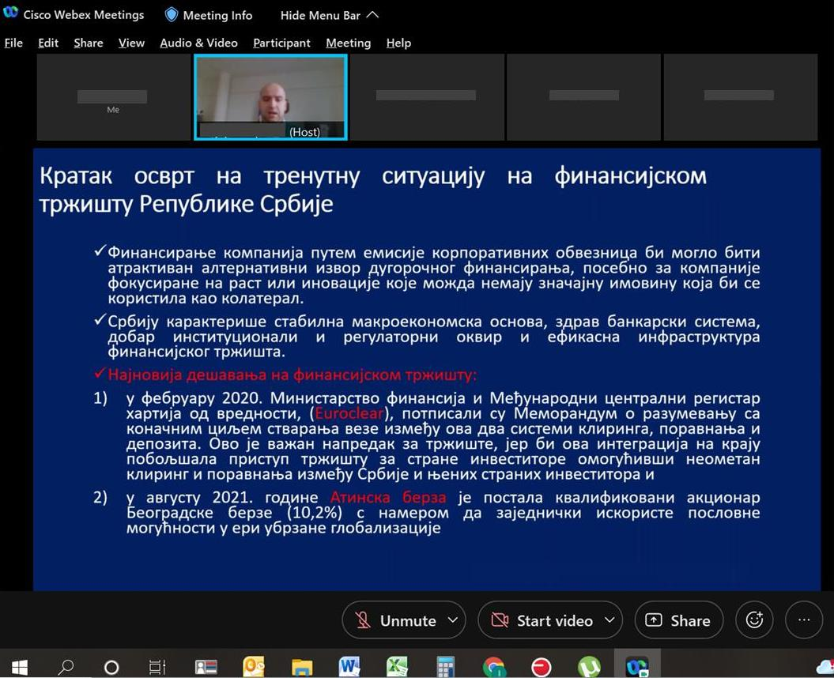Picture 1: On-line Public consultation in Belgrade, 21 December 2021
Special focus was given to project description, implementation arrangements, potential environmental and social impacts, grievance redress procedures, labor management, screening forms and development of environmental and social management plans during Project implementation.
The importance of labor management and most important provisions of WB Environmental and Social Standard ESS2: Labor and Working Conditions were also explained to the public during presentation of ESF documents.
There were no question nor comments raised by the attendees during Public Consultations and Public presentation of ESF documents.

DOCUMENTATION

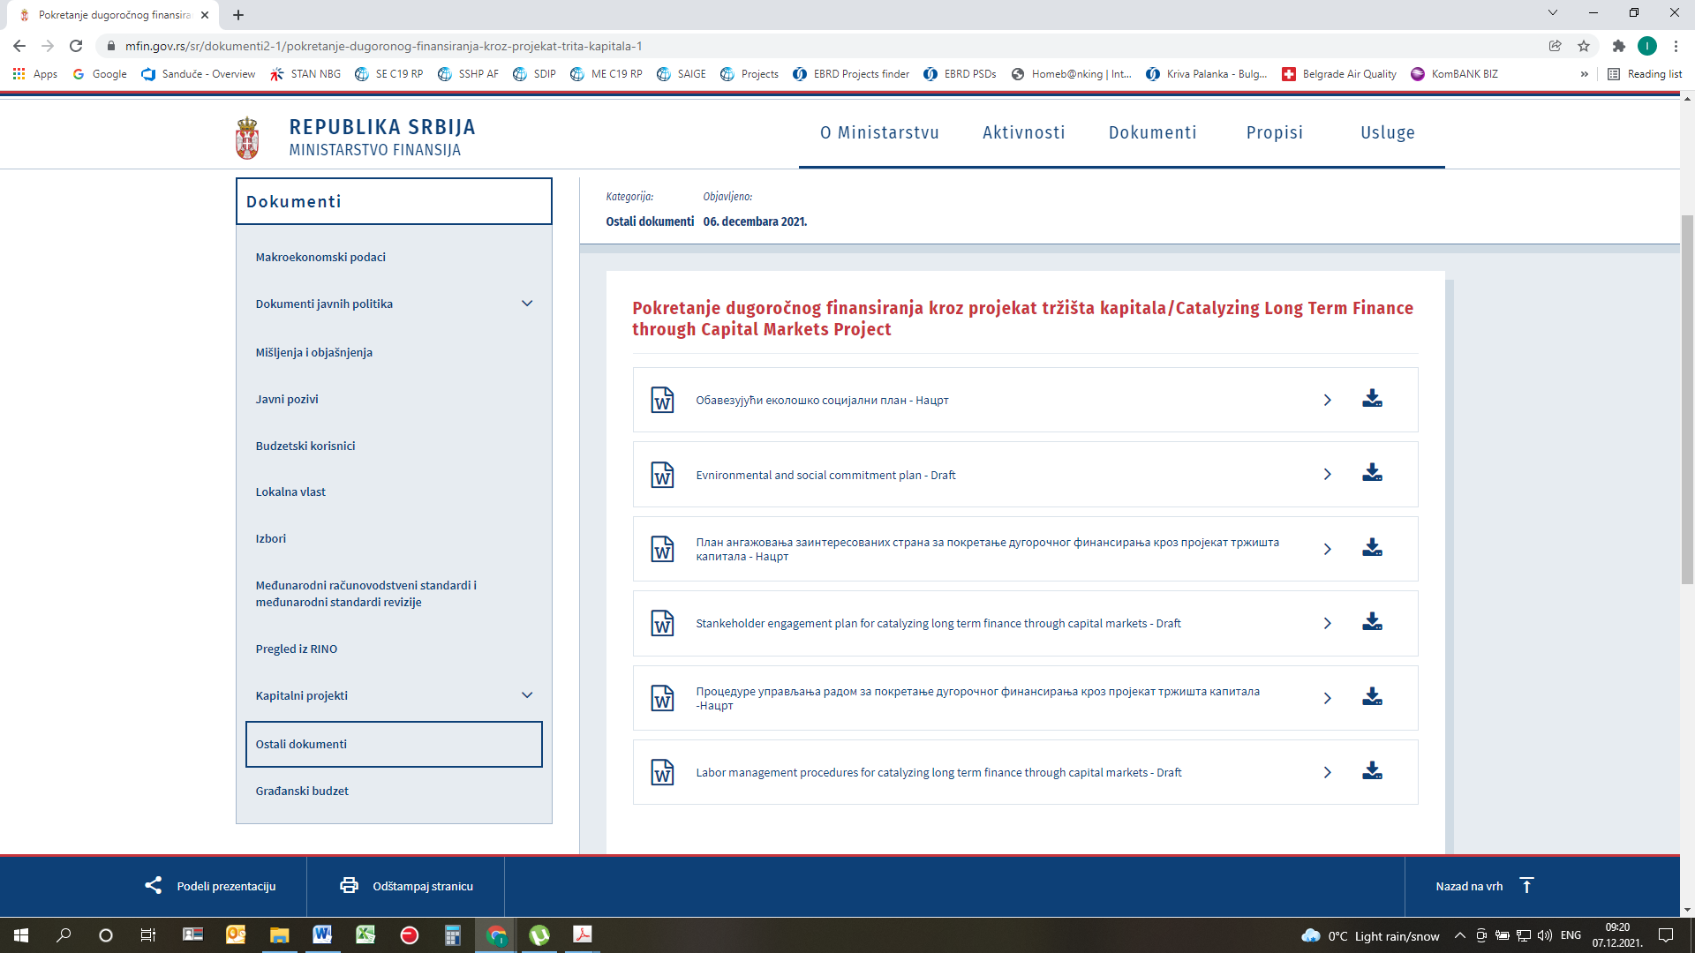
Picture 2: Public disclosure of Draft ESCP, SEP, LMP and ES Procedure on Ministry web site

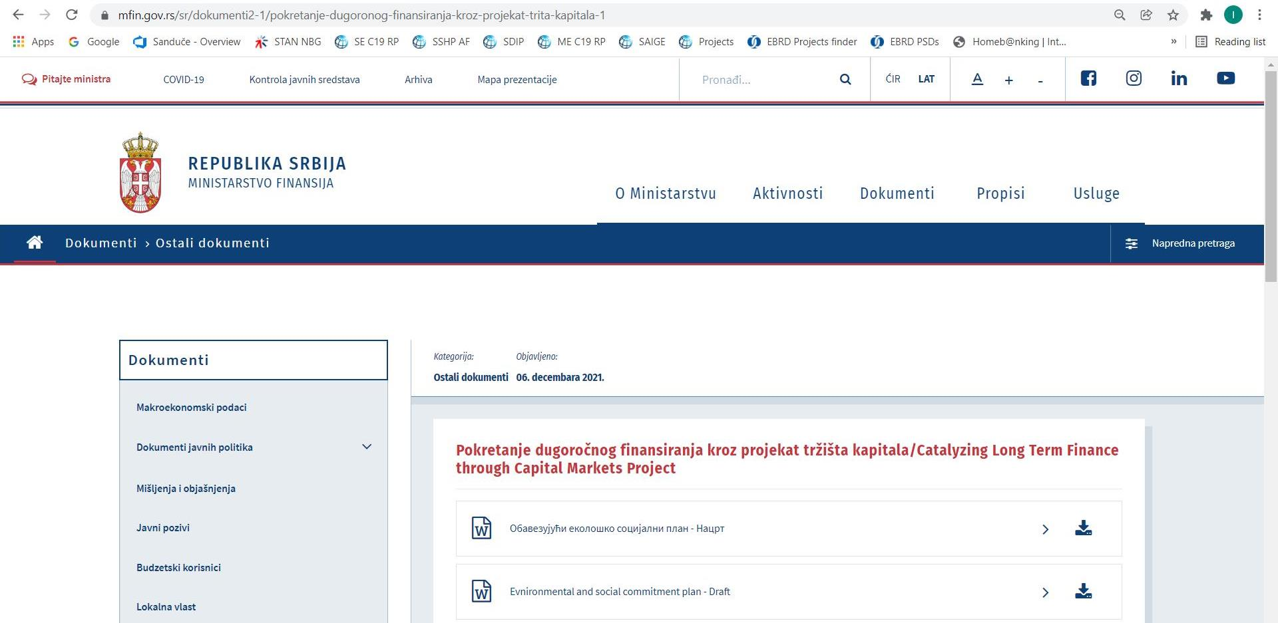
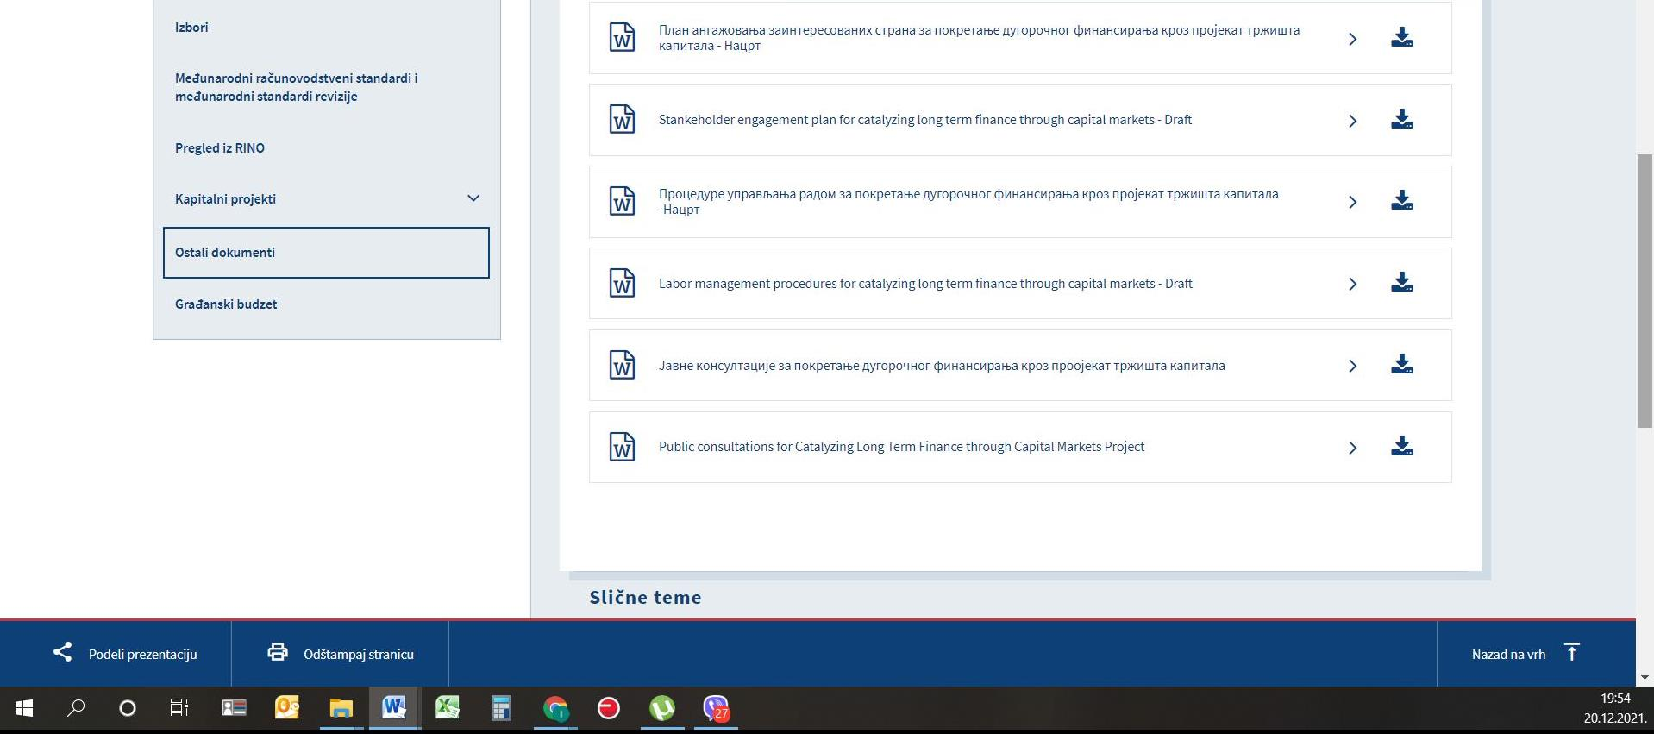
Picture 3: Announcement of public consultation on CLTFTCM Environmental documents on Ministry web site
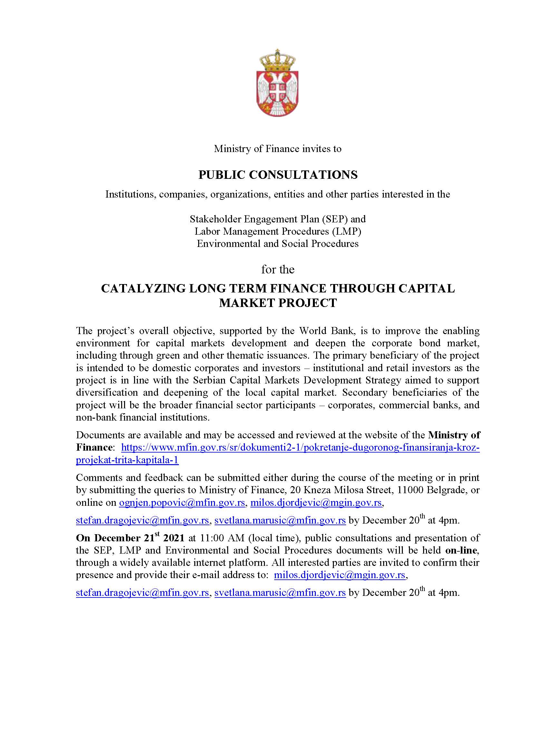
Picture 4: Announcement of public consultation on CLTFTCM Environmental documents on Ministry web site

- The ESF is accessible at - https://www.worldbank.org/en/projects-operations/environmental-and-social-framework. Latest accessed on November 3, 2021
These include: ILO Convention 87 on Freedom of Association and Protection of the Right to Organize, ILO Convention 98 on the Right to Organize and Collective Bargaining , ILO Convention 29 on Forced Labor ,ILO Convention 105 on the Abolition of Forced Labor 2 Guidance Note – ESS2: Labor and Working Conditions • ILO Convention 138 on Minimum Age (of Employment) • ILO Convention 182 on the Worst Forms of Child Labor • ILO Convention 100 on Equal Remuneration • ILO Convention 111 on Discrimination (Employment and Occupation
https://www.paragraf.rs/propisi/zakon_o_radu.html (Serbian version) https://www.paragraf.rs/propisi/employment-act-republic-serbiahtml (English version)
The term used in this context refers to professionals, skilled workers, or artists taking positions outside their home country, independently or being sent abroad by their employers, i.e. companies, universities, governments, or non-governmental organization.
https://www.paragraf.rs/propisi/zakon_o_bezbednosti_i_zdravlju_na_radu.html
https://www.minrzs.gov.rs/sites/default/files/2020-07/94-20%20PRAVILNIK%20ZARAZNE%20BOLESTI-converted.pdf
https://www.minrzs.gov.rs/sites/default/files/2020-07/plan%20primene%20mera%20%281%29.pdf
Such notification is the employer's obligation stipulated by Law on the Prevention of Harassment at the Workplace (2010), Rulebook on Conduct of Employers and Employees in Relation to Prevention and Protection from Harassment at Work (2010) and Law on Protection of Whistle Blowers (2014)

