Republic of Serbia
Ministry of Finance
Kneza Milosa 20
11000 Belgrade

Stakeholder Engagement Plan (SEP)
for
Catalyzing Long Term Finance Through Capital Markets (P176069)

Final

January 2023

Contents
1. INTRODUCTION 6
1.1 Project Description and Context 6
1.2 Purpose and justification for the SEP 8
1.3 National Legislation Requirements 8
1.4 World Bank’s Environmental and Social Standard on Stakeholder Engagement (EES10) 9
2. SUMMARY OF PREVIOUS STAKEHOLDER ENGAGEMENT ACTIVITISES 10
3. STAKEHOLDER IDENTIFICATION AND ANALYSIS 10
3.1 Project Affected Parties 11
3.2 Other Interested Parties 11
3.3 Disadvantaged or Vulnerable Individuals or Groups 12
3.4 Summary of stakeholder engagement needs and Analysis of their Interest and Influence 12
4. STAKEHODLER ENGAGEMENT PROGRAM 15
4.1. Purpose and timing of stakeholder engagement program 15
4.2 Proposed Strategy for Disclosure 15
4.3 Proposed Strategy for Consultation and engagement activities 15
5. RESOURCES AND RESPONSIBILITIES FOR IMPLEMENTING STAKEHOLDER ENGAGEMENT ACTIVITIES 25
5.1. Resources 25
5.2 Management Functions and Responsibilities 26
6. GRIEVANCE MECHANISM 26
6.1 Raising grievances 27
6.2 Grievance administration 27
6.3 Grievances and beneficiary feedback reporting 28
6.4 Grievance log 28
6.5 Monitoring and reporting on Grievances 29
7. World Bank Grievance Redress Service 30
8. MONITORING AND REPORTING 30
8.1 Reporting back to stakeholder groups 32

List of Figures
No table of figures entries found.

List of Tables
Table 1: Influence and interest matrix 13
Table 2: Level of stakeholder engagement based on their level of interest and level of influence 13
Table 3: Proposed Strategy of Consultation 16
Table 4: Tentative budget Categories for effective implementation of engagement activities 25
Table 5: CFD contact details. 29
Table 6: Monitoring indicators 30

ANNEX 1 – REPORT ON PUBLIC CONSULTATIONS
ABBREVIATIONS
CGD | Central Grievance Desk
E&S | Environmental and Social
ESCP | Environmental and Social Commitment Plan
ESF | Environmental and Social Framework
ESMF | Environmental and Social Management Framework
ESMP | Environmental and Social Management Plan
ESS | Environmental and Social Standards
GM | Grievance Mechanism
GoS | Government of Serbia
GRS | Grievance Redress Service
MoF | Ministry of Finance
NGO | Non-Governmental organization
OG | Official Gazette
OHS | Occupational Health and Safety
OIP | Other Interested Parties
PIU | Project Implementation Unit
RS | Republic of Serbia
SOE | State Owned Enterprise
WB | World Bank

GLOSSARY
Consultation: The process of sharing information and getting feedback and/or advice from stakeholders and taking these views into account when making project decisions and/or setting targets and defining strategies.
Environmental and Social Standards (ESSs): The 10 Environmental and Social Standards (ESSs) setting out the requirements that apply to all new World Bank investment project financing enabling the World Bank and the Borrower to manage environmental and social risks of projects.
Project Affected parties: includes those affected or likely to be affected by the project because of actual impacts or potential risks to their physical environment, health, security, cultural practices, well-being, or livelihoods. These stakeholders may include individuals or groups, including local communities.
Other interested parties: refers to individuals, groups, or organizations with an interest in the project, which may be because of the project location, its characteristics, its impacts, or matters related to public interest. For example, these parties may include regulators, government officials, the private sector, the scientific community, academics, unions, women`s organizations, other civil society organizations, and cultural groups.
Stakeholders: Collective reference to individuals or groups who: (a) are affected or likely to be affected by the project (project-affected parties); and (b) may have an interest in the project (other interested parties).
Stakeholder engagement: is the continuing and iterative process by which the Borrower identifies, communicates, and facilitates a two-way dialogue with the people affected by its decisions and activities, as well as others with an interest in the implementation and outcomes of its decisions and the project. It takes into account the different access and communication needs of various groups and individuals, especially those more disadvantaged or vulnerable, including consideration of both communication and physical accessibility challenges. Engagement begins as early as possible in project preparation because early identification of and consultation with affected and interested parties allows stakeholders views and concerns to be considered in the project design, implementation, and operation
Recalibrating Stakeholder engagement: Adapting activities of stakeholder engagement in the times of the COVID-19 pandemic and the need for physical distancing
Stakeholder Engagement Plan (PSEP): This Plan document prepared to guide development of sub-project specific SEPs, and ensure effective stakeholder engagement while transitioning towards them.

INTRODUCTION

Project Description and Context

The project’s overall objectives are to (i) improve the enabling environment for capital markets development and (ii) deepen the corporate bond market, including through green and other thematic issuances.

The project’s objective will be addressed from three angles, with two components and several sub-components. The three angles are: (1) improving the enabling environment – by (i) setting up a capital markets unit in the Ministry of Finance (MoF) and strengthening the capital market institutions, particularly the SSC and the CSD by aligning them with the relevant international principles (i.e., the IOSCO Principles); (ii) creating a one-stop shop and supporting technical assistance (TA) for implementing the CMDS as well as for strengthening BELEX, (2) deepening the supply side (issuing more corporate bonds and/or other non-government securities instruments) – by creating a corporate bond issuance program, including a specific focus on green and other thematic issuances, with an explicit emphasis on climate financing, and 3) deepening the demand side (attracting more investors) – by simplifying the taxation regime for capital markets based on a comprehensive analysis completed in 2022 and aiming to identify a solution for dormant accounts. The project design will be structured around two main components with several sub-components: Component 1 - Institutional, Legal and Regulatory Reforms and Component 2 - Corporate Bond Issuer Program (Figure 1).

Figure 1: Overall Project Objective and its link to Project Components

An overarching output of the project will be the development of a special unit focused on capital markets (one-stop-shop) for capital markets services. The objective of the one-stop shop will be to provide a comprehensive set of services related to capital markets development. It will be comprised of qualified staff from MoF and SSC and relevant government agencies and will be housed within the MoF. The one-stop shop is expected to be responsible for all capital market related activities involving the general public and/or private sector entities. The one-stop shop will monitor the implementation of the CMDS, support the implementation of non-regulatory activities, coordinate inter-institutional cooperation, manage the web-based portal, and provide centralized support to market participants. For example, the one-stop shop will lead the creation of an interactive web-based portal based on the internet in which the public will have a centralized, digitalized system of information related to corporate bond issuance and other capital markets products involving investment opportunities and legal regulations for both domestic and international investors. It will also be the main web-based portal for issuers looking to address requirements of the key authorities. The interactive web-based portal would be a deliverable of the one-stop shop amongst other capital market development activities. The one-stop-shop can contribute to financial education with the introduction of capital market products and knowledge materials placed on the website. It can also raise awareness regarding the need to develop green and climate financing in the country. The one-stop shop will execute critical tasks and activities under both Component 1 and 2 as described below. The CMDS identified the creation of an online, portal-based one-stop shop as crucial to centralize the current disparate, fragmented nature of capital markets investing in Serbia – information spans across various agencies and linkages across several existing policies and legal frameworks. Similar initiatives have taken place in Sri Lanka to streamline capital markets information.

Component 1: Institutional, Legal and Regulatory Reforms
This component will focus on supporting the government in strengthening the institutional, legal, and regulatory framework for capital markets development. The subcomponents are: 1.1 MoF Capital Markets Unit, 1.2 Strengthening Serbia’s Securities Commission and Central Securities Depository, 1.3 Strengthening of BELEX, 1.4 Capital market taxation reform, and 1.5 Other Technical Assistance to support implementation of the Capital Markets Development Strategy.

Across the component, support will be provided to the MoF (MoFFS and CFU) for project management and operating costs, including the financing of costs related to procurement, financial management, monitoring and evaluation, reporting, safeguards and technical oversight, policy coordination, PBC’s independent verification, and carrying out independent technical audits and the Project’s independent financial audits.
Component 2: Corporate Bond Issuer Program (CBIP)
This component will focus on expanding the corporate bond issuer base. Broadly, this component will facilitate corporate bond issuances in local currency (Serbian Dinar, RSD) starting from the identification of potential CBIs to the completion of issuance of bonds either privately placed or publicly listed. In select cases, post-issuance activities will also be supported, especially around green and thematic bonds. A special taskforce in the MoF supported by the SSC and other relevant stakeholders will identify an initial long list of potential CBIs, assess their needs regarding technical assistance, training, and guidance to enable these companies to prepare for issuance, and then guide them through the bond issuance process. This will involve building a comprehensive program by working with entities such as law firms, financial advisory firms, credit rating agencies, and other critical professional service providers as needed. Participating and selected CBIs will not receive funds from the project directly. Thus, the project will provide capacity building and technical assistance to the MoF to support potential CBIs throughout the preparatory process to issue corporate bonds. The MoF and SSC consider that that over 200 companies may have potential for being admitted to the program, of which approximately 15 to 20 non-financial companies may be made ready for issuance in the near term if they are provided support.
The initial step will be the establishment of the task force and the identification of companies for the long list of firms accepted into the program. The MoF-led task force will administer and implement the corporate bond issuer program (CBIP) with acceptable staff and procedures in place to successfully execute the program. The task force will – at a minimum – include the MoF, SSC, and Chamber of Commerce. A representative from the institutional investors would also be beneficial. The task force will cast a wide net to elicit interest from potential CBIs by building on the SBRA list, the work undertaken as part of the preparation of the CMDS, and a collaboration with the Chamber of Commerce, which has excellent connections to companies across sectors. Preliminary criteria for firms to be admitted to the long list and be able to benefit from the assistance include, among others: (i) willingness expressed through a letter of commitment to go through necessary improvements to corporate governance and financial processes, as identified, and to accept transparency requirements with bondholders, (ii) no negative information in relevant credit registries, (iii) profit making for three years – with exception for 2020 if COVID-19 related, (iv) minimum operational revenue, (v) maximum debt/ equity ratio and minimum interest coverage ratio, and (vi) not involved in sectors that fall within the negative list of the WBG (such as sectors that conflict with WBG ESG requirements and may pose reputational risks to the WBG and MoF/SSC/the program.) There will be no sectoral focus in the program as long as corporates meet these requirements. These preliminary criteria which will also be included in the Project Operations Manual.
The implementing agency for the operation will be the Ministry of Finance, more specifically the Ministry of Finance’s Department in charge of overseeing the financial sector, MoFFS. The project will be building upon the MoFFS’s successful experience in implementing previous World Bank financial sector projects. This project will hone and strengthen MoFFS’s capacity to execute specific capital markets activities within the financial sector through the establishment of the CMPRU under the MoFFS; project financing has been allocated accordingly for this purpose. Given the specific nature of the project, the MoFFS will be closely working with the SSC on the implementation of this project in order to properly align it with the oversight and regulatory requirements of the capital markets framework in Serbia. Notwithstanding that the governance of the project is expected to include a task force with, at the minimum, the MoF, SSC, CSD, BELEX and the Chamber of Commerce represented, in order to improve the coordination of (and commitment to) all project components, the ultimate leadership will be with the MoF, and oversight of the project will be in the hands of the MoFFS, which will house the CMPRU.
The Central Fiduciary Unit (CFU) within the MoF will be in charge of fiduciary responsibilities for the project. The CFU was established within the MoF in 2017, with the aim to provide fiduciary support to all World Bank supported projects in Serbia. It was agreed that the CFU would be responsible for procurement and financial management activities for all new World Bank supported projects. The CFU is currently managing fiduciary responsibilities for nine ongoing WB projects, with costs shared proportionally and one grant. The CFU is adequately staffed with experienced and qualified finance and procurement professionals. Additional needs that may result from more projects being added to the CFU portfolio are assessed on a continuous basis. The PBC part of the project is intended to finance expenditures included in the state budget that are incurred as a result of the implementation of the CMDS. The selected budget lines from the MoF, SSC and CSD will include salaries and contract services that are required to implement and execute the CMDS.

The environmental and social risks are rated as Moderate since the project is not expected to have significant environmental and social impacts. The project will not finance nor support any civil works, therefore no adverse impacts on biodiversity, habitats, and cultural heritage are expected. Social risks and impacts are limited in scope and duration and may be managed with standard mitigation measures. It is not anticipated that the project will adversely affect any vulnerable or disadvantaged groups. While the intrinsic social and environmental risks and impacts of the direct project activities are low, the contextual risks of the sectors in which beneficiary corporates operate result in an overall E&S risk rating of Moderate. Beneficiary corporates will commit to following national environmental and social legislation. The Project will apply the World Bank Group Exclusion List and will not support any firms who engage child and forced labor. Furthermore, Project aims to bring some positive environmental impacts in terms of supporting alignment of Serbia’s framework to the EU’s Sustainable Financing Initiatives and with the EU Green Bond Standard and broader labels for green financial products. Project will also support establishment of a One-Stop-Shop for capital markets services that will provide a comprehensive set of services related to capital markets development and could also broadly raise awareness regarding the need to develop green and climate financing in the country.

Purpose and justification for the SEP
Operations and activities for which the World Bank`s Investment Project Financing (IPF) is sought after October 1,2018, fall under the application of the Environmental and Social Framework (ESF). The ESF comprise, inter alia, the 10 Environmental and Social Standards which set out mandatory requirements for the Borrower and the Project. Under the ESS10, a Stakeholder Engagement Plan (SEP) should be developed prior to Project appraisal that sets out the principles and procedures for stakeholder engagement in a manner that is consistent with ESS10.
The purpose of the present Stakeholder Engagement Plan (SEP) is to outline the target groups and methods of stakeholder engagement and the responsibilities in the implementation of stakeholder engagement activities. The intention of the SEP is to activate the engagement of stakeholders in a timely manner during project preparation and implementation. Specifically, SEP serves the following purposes: (i) stakeholder identification and analysis; (ii) planning engagement modalities and effective communication tools for consultations and disclosure; (iii) defining role and responsibilities of different actors in implementing the SEP; (iv) defining the Project’s Grievance Mechanism (GM) and (v) providing feedback to stakeholders; (vi) monitoring and reporting of the SEP.
The stakeholder engagement will be integrated into project’s environmental and social performance and project design and implementation. The adequacy of the engagement methods shall be part of the Monitoring & Evaluation (M&E) segment of the Project.

National Legislation Requirements
The commitments and requirements of the Republic of Serbia to citizen engagement are not residing under a single self-standing law or regulation. However, the recognition of importance of citizen engagement is infused in the legal system and clearly recognized by mandatory procedures provided under individual laws. Serbia having acquired the EU candidate country for membership status, is taking a huge effort to reach environmental standards in line with the EU acquis which extends to issues of stakeholder and citizen engagement as well.
From the highest legal act down to an ample normative framework comprising the Serbian legal system, a strong commitment and openness to stakeholder engagement is evident. Key laws governing the stakeholder and citizen engagement activities include, but are not limited to:
The Constitution of the Republic of Serbia (2006) proclaims the rule of law and social justice, principles of civil democracy, human and minority rights and freedoms, and commitment to European principles and values. The Article 74 proclaims the right to healthy environment and grants the right to timely and comprehensive information on the state of the environment.
The Law on free access to information of public interest (2004 as amended in 2021) states that governmental agencies, social associations and officials are required to provide each person with the possibility of receiving and becoming acquainted with documents of public interest, except in cases anticipated by law. shall govern the rights of access to information of public importance held by public authorities, with a view to exercising and protecting the public interest to know and attaining a free democratic order and an open society. By virtue of this Law access to information shall be granted to all stakeholders, including every natural person or legal entity upon written request unless otherwise regulated by the Law. Within 15 days of receipt of a request at the latest, the authority shall inform the applicant whether the requested information is held, and grant him/her access to the document containing the requested information or issue or send to the applicant a copy of the document, as the case may be.
Law on Public Information and Media (2014 as amended in 2015 and 2016) stipulates that public information is free and is not subject to censorship, that the public has the right and the interest to be informed on issues of public interest, that monopoly in the media is not allowed, that information on the media is public.
The Law on Environmental Impact Assessment (2004 as amended in 2009) provides categorization of industries and projects and identifies types of environmental assessment required against respective categories of industries or projects and provides procedures for disclosure, presentation and consultation requirements, and sets these as mandatory with a disclosure minimum of a minimum of 20 days.
The Republic of Serbia ratified the Aarhus Convention on Access to information, public participation in decision-making and access to justice in environmental matters and it links environmental and human rights and is based on the belief that it is a basic right of present and future generations to live in an environment adequate to health and wellbeing. The convention is focused on achieving this through the implementation of three pillars: rights of access to information, access to decision-making, and access to justice.
Other stakeholder engagement, disclosure and transparency requirements within certain topics and sectors are embedded in the applicable laws regulating each of the treated subject. They are broadly compliant to the requirements of ESS10 but have certain shortcomings when it comes to active outreach and continuous engagement strategies.

World Bank’s Environmental and Social Standard on Stakeholder Engagement (EES10)
The World Bank’s ESS 10, “Stakeholder Engagement and Information Disclosure”, recognizes “the importance of open and transparent engagement between the Borrower and project stakeholders as an essential element of good international practice”. Specifically, the ESS10 requires the following:
- “Borrowers will engage with stakeholders throughout the project life cycle, commencing such engagement as early as possible in the project development process and in a timeframe that enables meaningful consultations with stakeholders on project design. The nature, scope and frequency of stakeholder engagement will be proportionate to the nature and scale of the project and its potential risks and impacts.
- Borrowers will engage in meaningful consultations with all stakeholders. Borrowers will provide stakeholders with timely, relevant, understandable and accessible information, and consult with them in a culturally appropriate manner, which is free of manipulation, interference, coercion, discrimination and intimidation.
- The process of stakeholder engagement will involve the following, as set out in further detail in this ESS: (i) stakeholder identification and analysis; (ii) planning how the engagement with stakeholders will take place; (iii) disclosure of information; (iv) consultation with stakeholders; (v) addressing and responding to grievances; and (vi) reporting to stakeholders.
- The Borrower will maintain and disclose as part of the environmental and social assessment, a documented record of stakeholder engagement, including a description of the stakeholders consulted, a summary of the feedback received and a brief explanation of how the feedback was taken into account, or the reasons why it was not.” (World Bank, 2017: 98).

SUMMARY OF PREVIOUS STAKEHOLDER ENGAGEMENT ACTIVITISES
The specific nature of the Project required a broad engagement with various project stakeholders with main discussions between the World Bank and the Government, institutional and sector specific institutional Stakeholders. The preparation of the Project was affected by the unparalleled constrains the global COVID-19 pandemic imposed to travels and face-to-face meetings.
Given that the Project is part of a comprehensive, broad effort to develop Serbia’s capital markets through complementary activities and/or building upon existing capital markets assistance by several development partners: notably, IBRD, IFC, EBRD and the IMF, numerous discussions and communication exchange between the World Bank and government agencies at the national, regional and local level have taken place. Currently, EBRD is supporting the GoS with the development of the Capital Markets Development Strategy and developing an in-depth study on institutional investors, a key constraint for capital market development in Serbia. This operation builds upon the capital markets work of the EBRD; there is a close collaboration between EBRD and IBRD on this topic.
Since 2020 the engagement with various stakeholder is ongoing. A round table about the development of the capital market in Serbia was held in 2020. The event gathered representatives of the Ministry of Finance, National Bank of Serbia, Belgrade Stock Exchange, Central Securities Depository and Clearing House, Securities Commission and their international partners from the World Bank, European Bank for Reconstruction and Development (EBRD), United States Agency for International Development (USAID) and the United Nations Development Program (UNDP).

On December 6, 2021, the Ministry of Finance (MoF) publicly disclosed in English and Serbian languages draft of the following ESF documents: Stakeholder Engagement Plan (SEP), Labor Management Procedures (LMP), ES Procedure and Environmental and Social Commitment Plan (ESCP). The public consultations on the ESF documents were held on December 21, 2021 and detailed report is included in the Annex of the SEP”.

STAKEHOLDER IDENTIFICATION AND ANALYSIS
ESS 10, read in conjunction with ESS1, recognizes the following categories of stakeholders:
1) Project Affected Parties. These includes those likely to be affected by the project because of actual impacts or potential risks to their physical environment, health, security, cultural practices, wellbeing, or livelihoods. These stakeholders may include individuals or groups, including direct project beneficiaries and local communities. They are the individuals or households most likely to observe/feel changes from environmental and social impacts of the project.
2) Other Interested parties (OIPs) refers to: individuals, groups, or organizations with an interest in the project, which may be because of the project location, its characteristics, its impacts, or matters related to public interest. For example, these parties may include regulators, government officials, the private sector, the scientific community, academics, unions, women’s organizations, other civil society organizations, and cultural groups. The stakeholder identification has been expanding to a wider area than the project will affect, since the locations have not all been identified and important details of project activities are still under development.
3) Disadvantaged/Vulnerable Individual or Groups. Includes those who may be more likely to be adversely affected by the project impacts and/or more limited than others in their ability to take advantage of a project’s benefits. Such an individual/group is also more likely to be excluded from/unable to participate fully in the mainstream consultation process and as such may require specific measures and/ or assistance to do so. This will take into account considerations relating to age, including the elderly and minors, disability, gender, and including circumstances where they may be separated from their family, the community or other individuals upon whom they depend.
The Project has multiple stakeholders from government, private sector, research sector and donor organizations involved in Serbia and relevant to the Project. The stakeholder engagement risk is considered low because the Project will is not anticipated to directly affect people and communities, and will mainly work with corporates, other government agencies and research organizations.

Project Affected Parties
Serbian capital market is regulated and supervised by the Serbia Securities Commission (SSC). The SSC is an autonomous and independent organization of the Republic of Serbia. It regulates and supervises local capital markets structures and infrastructures, capital markets intermediaries, public offerings, investment funds and their managers, in accordance with the principles set in the law and regulation prepared by the MoF. Regulation does not require credit ratings for bonds and there are no credit rating agencies in the country. Most up to date legislations and regulations are available in English on the SSC’s website. The SSC is accountable to the National Assembly, which appoints the commissioners for a period of five years.

  - Direct Beneficiaries:
The primary project beneficiaries will be the:
- Ministry of Finance, will benefit from the increased capacity through additional technical and advisory hires
- State Security Commission, Central Security Depositary, BELEX will benefit from the increased capacity through additional technical and advisory hires and
- Selected Serbian corporates - will directly benefit from the Corporate Bond Issuer Program. The program will provide a comprehensive suite of technical, financial, and advisory services. The enterprises will benefit from in-depth, individually tailored assistance for corporate debt financing. On a secondary level, the selected enterprises will benefit from diversified corporate debt financing sources (beyond bank financing), which will enhance the financial acumen of the enterprises and improve the availability of long-term financing for issuers and their resilience during the credit cycle.

Other Interested Parties
'Other Interested Parties’ constitute individuals, groups, entities that may not experience direct impacts from the project but who consider or perceive their interests as being affected by the project and/or who could affect the project and the process of its implementation in some way. Accordingly, there are a number of other stakeholders who have a stake, have expressed, or may express interest due to a variety of reasons. They include project implementing agencies, project partners, political institutions, service providers, host communities, civil society organizations, NGOs, religious institutions, political authorities, academic institutions, and project beneficiaries.
These are also recognized as secondary beneficiaries of the project which may include broader financial sector participants – corporates, commercial banks, and non-bank financial institutions. The new portal, the one-stop shop, and the financial education programs embedded within both aspects and the selected TA will improve the overall market knowledge about capital markets, including the benefits of corporate debt financing from sources beyond banks.
3.3 Disadvantaged or Vulnerable Individuals or Groups
It is not anticipated that the project will adversely affect any vulnerable or disadvantaged groups.
Project beneficiaries are well established companies and do not tend to belong to disadvantaged/vulnerable groups in the society. Non-discrimination principles will be reflected in the TA provided to selected companies embedded in the design of programs and the proposed stakeholder engagement activities.

The labor force participation of women in enterprises as full-time workers, managers or their representation within the firm’s ownership is relatively on par or exceeds averages found in Europe and Central Asia (ECA). For example, 18.2 percent of firms have a female top manager compared to 18.5 percent in ECA, and only 28.5 percent of firms have part female ownership. Being aligned with the ECA average masks the fact that female representation in management positions and firm ownership is unfavorable across the region. Within relatively larger firms, representation of women is even less favorable. Women also earn around 17 percent less than men, even when characteristics such as education and work experience are accounted for. In terms of vertical segregation, employed women, on average, have better jobs than men. Almost half of employed women (44.7 percent) work in the four most highly paid occupations (managers, professionals, technicians, and clerks), compared with fewer than one third of men (30.2 percent) (World Bank 2016). Preliminary information suggests that only one of the seven corporate bonds issued in 2020 was issued by a women-managed firm. Pre-identification of corporates that are interested in issuing bonds will mainly be determined by financial readiness of the firm to seek bond financing in order to ensure financial sustainability of the bond issuances as well as governance and transparency considerations. Nevertheless, specific training regarding the benefits of higher levels of inclusion from a gender perspective will be included in the financial education program and the corporate bond issuance program.

3.4 Summary of stakeholder engagement needs and Analysis of their Interest and Influence
Identified stakeholder groups and their level of influence cross-referenced with their interest they may have in the project will determine the type and frequency of engagement activities necessary for each group. Using the color coding of interest and influence matrix below will help determine where to concentrate stakeholder engagement efforts and why.
The table below identifies the key stakeholder groups and categories, the nature of their interest in the project and their level of interest in and influence over the project and is based on the color code in the matrix below

Table 1: Influence and interest matrix
Level of Influence
High | Involve/engage | Involve/Engage | Partner
Medium | Inform | Consult | Consult
Low | Inform | Inform | Consult
 | Low | Medium | High | Level of Interest

Table 2: Level of stakeholder engagement based on their level of interest and level of influence

Project Stakeholder Group |  | Nature of interest | Level of interest |  |  | Level of Influence |  | Level of engagement
 | PIU hosed by MoF | Project management and implementation, oversight, reporting, financial, environmental and social risk management, grievance management, SEP implementation and coordination | High |  |  | High |  | Partner
 | The World Bank | Interested in achievement of Project Development Objectives and compliance to E&S Standards of the Project | High |  |  | High |  | Partner
 | Chamber of Commerce | Assisting in mitigating potential challenges with identifying a sufficient number of corporates interested in and willing to participate in the program and preparing them adequately for issuance. | High |  |  | High |  | Partner
 | Non-financial Private Companies suitable to participate in the Corporate Bond Issuer Program | Potential beneficiaries | High |  |  | High |  | Partner
 | Non-Financial SOEs | Potential beneficiaries | High |  |  | High |  | Partner
 | Potential investors (domestic and Foreign) | Creating the demand side for the Bond issuance Program | High |  |  | High |  | Partner
 | Academic institutions (eg. Economic Faculty) | Potential concerns over regarding environmental and social impacts and project designs  The project may provide a knowledge sharing avenue | Medium |  |  | Low |  | Inform
 | National media (Radio, TV, Newspaper) | Enables wide and regular dissemination of information related to the Project, ensures its visibility and facilitates stakeholder engagement |  | Medium | Low |  | Inform

STAKEHODLER ENGAGEMENT PROGRAM

Purpose and timing of stakeholder engagement program
The main goals of the stakeholder engagement program is to inform, disclose and consult on various project documents and activities early on to establish a dialogue with Project Stakeholders from project planning though implementation and operation. All ESF documents prepared in anticipation and in expectation of the financing agreement from the World Bank will be disclosed at least 10 days before public consultations on the websites of the PIU and WB. The disclosure packages will include:
- Project announcements,
- Brief description of Project,
- Description of public consultation arrangements (time, place…)
- Ways of submitting comments and feedback
- Key deadlines
- The respective draft ESF documents

Project information and schedule of project activities will be provided to stakeholders in timely manner and project shall take into consideration comments and concerns received during consultations. Information disclosure will provide information on a manner in which stakeholders can to review information and provide their views and feedback.

4.2 Proposed Strategy for Disclosure
ESF documents will be disclosed electronically on the websites of the PIU and SSC and will be available in Serbian and English at
- the website of the MOF (http://www.mfin.gov.rs/)
- the websites of SSC (https://www.sec.gov.rs/index.php/sr/), CSD (http://www.crhov.rs/), BELEX (https://www.belex.rs/eng/)
- through social media campaigns.
Printed copies will be made available at the PIU premises and during public consultation.

4.3 Proposed Strategy for Consultation and engagement activities
Various stakeholder engagement activities are proposed to ensure awareness and meaningful consultations about Project activities. Targeted messaging will encourage the participation of women and highlight Project characteristics that are designed to respond to their needs and increase their access to Project benefits.
Different engagement methods are proposed, but driven by the COVID-19 considerations and restrictions the Project will adapt virtual communication and consultation methods taking into account social distancing requirements. Hence, alternative ways will be adopted in accordance with the local laws, policies and new social norms in effect to mitigate the virus transmission, as well as relevant WHO guidelines and the Banks’ Technical Note: Public Consultations and Stakeholder Engagement in WB-supported​ operations when there are constraints on con​ducting public meetings. The alternative approaches to be practiced for stakeholder engagement will include:
- small groups consultations if smaller meetings are permitted, or making reasonable efforts to conduct meetings through online channels (e.g. webex, zoom, skype etc.); Where possible and appropriate, create dedicated online platforms and chat groups appropriate for the purpose, based on the type and category of stakeholders;
- diversifying means of communication and relying more on social media, chat groups, dedicated online platforms & mobile Apps (e.g. Facebook, Twitter, WhatsApp groups, ViberApp groups, project weblinks/websites etc.);
- employing traditional channels of communications such TV, radio, dedicated phone-lines, SMS broadcasting, public announcements when stakeholders do not have access to online channels or do not use them frequently.
- Chose venues carefully based on hygiene and sanitation standards that can be achieved during the meetings;
- Employ traditional channels of communications (TV, newspaper, radio, dedicated phone-lines, and mail) when stakeholders to do not have access to online channels or do not use them frequently. Traditional channels can also be highly effective in conveying relevant information to stakeholders, and allow them to provide their feedback and suggestions;
- Where direct engagement with project affected people or beneficiaries is necessary, identify channels for direct communication with each affected household via a context specific combination of email messages, mail, online platforms, dedicated phone lines with knowledgeable operators;
Each of the proposed channels of engagement should clearly specify how feedback and suggestions can be provided by stakeholders

Table 3: Proposed Strategy of Consultation

Project stage | Target stakeholders | Topic(s) of engagement | Method(s) used | Frequency | Responsibilities
PLANNING AND PREPARATION PHASE | - Non-financial Private Companies suitable toe participate in the Corporate Bond Issuer Program  - Large Companies  - ( 250 + Employees) | Regular updates about the Project  - Criteria for the long list of potential corporate bond issuers to participate in the Corporate Bond Issuer Program;  - Criteria for the ready-to-issue list of potential corporate bond issuers;  - Types of assistance that can be provided to participants in the Corporate Bond Issuer Program based on needs assessment, and cost sharing arrangements.  - Explore interest levels of enterprises to issue corporate bonds as well as financial suitability.  Opportunities and advantages of funding the general corporate operations, operational financing, working capital and seasonal needs depending on the business sector.  Information of green bonds and how these can be used to finance specific projects  cast a wide net to elicit interest from potential corporate bond issuers by building on the SBRA list  Exploring the willingness expressed through a letter of commitment to go through necessary improvements to corporate governance and financial processes, as identified, and to accept transparency requirements with bondholders,  Presentation of the Exclusion list  Broader approach to financial education around capital markets, including the benefits to publicly list companies versus debt financing via banks, and broader financial education for the population regarding long-term saving options, including insurance and pension funds, which may indirectly support expansion of the institutional investor base. | Public meetings.  Webinars  Workshops  Trainings/workshops.  Public notices;  Direct contacts and meetings  Electronic publications via online/social media and press releases;  Dissemination of hard copies at designated public locations; Press releases in the local media;  Information leaflets and brochures; audio-visual materials,  appropriate adjustments to consultation formats in order to take into account the need for l distancing (e.g., use of mobile technology such as telephone calls, SMS, etc). | Continuous through the Project  Communication through mass/social media (as needed); | PIU /MoF  SSC  MoF Led Task Force in collaboration with the Chamber of Commerce
- Non-financial Private Companies suitable toe participate in the Corporate Bond Issuer Program
- Medium Companies
- ( 50 + Employees)

- Non-financeila Private Companies suitable toe participate in the Corporate Bond Issuer Program
- Large and Medium Companies
- ( 250 + Employees and 50+ )
- Women owned/Led
 | - All of the above once admitted to  - the Corporate Bond Issuer Program | Identification of needs for support  Information on available support  (Corporate governance reviews, potential restructuring assistance, especially related to corporate governance or financial processes, training around capital market products and activities, professional auditing, obtaining a credit rating, and financial/ legal advisory fees)  Inform about post issuance support eligible under the Project  financial education/information about alternatives to bank financing  Broader approach to financial education around capital markets, including the benefits to publicly list companies versus debt financing via banks, and broader financial education for the population regarding long-term saving options, including insurance and pension funds, which may indirectly support expansion of the institutional investor base. | Public meetings.  Webinars  Workshops  Trainings/workshops.  Public notices | Continuous through the Project | PIU /MoF  SSC  MoF Led Task Force in collaboration with the Chamber of Commerce
 | State Owned Enterprises suitable to participate in the Corporate Bond Issuer Program | Regular updates about the Project  (a) Criteria for the long list of potential corporate bond issuers to participate in the Corporate Bond Issuer Program;  (b) Criteria for the ready-to-issue list of potential corporate bond issuers;  (c) Types of assistance that can be provided to participants in the Corporate Bond Issuer Program based on needs assessment, and cost sharing arrangements.  Explore interest levels of enterprises to issue corporate bonds as well as financial suitability.  Opportunities and advantages of funding the general corporate operations, operational financing, working capital and seasonal needs depending on the business sector.  Information of green bonds and how these can be used to finance specific projects  cast a wide net to elicit interest from potential corporate bond issuers by building on the SBRA list  Exploring the willingness expressed through a letter of commitment to go through necessary improvements to corporate governance and financial processes, as identified, and to accept transparency requirements with bondholders,  Presentation of the Exclusion list  Broader approach to financial education around capital markets, including the benefits to publicly list companies versus debt financing via banks, and broader financial education for the population regarding long-term saving options, including insurance and pension funds, which may indirectly support expansion of the institutional investor base. | Public meetings.  Webinars  Workshops  Trainings/workshops.  Public notices;  Direct contacts and meetings  Electronic publications via online/social media and press releases;  Dissemination of hard copies at designated public locations; Press releases in the local media;  Information leaflets and brochures; audio-visual materials,  appropriate adjustments to consultation formats in order to take into account the need for l distancing (e.g., use of mobile technology such as telephone calls, SMS, etc). | Continuous through the Project  Communication through mass/social media (as needed); | PIU /MoF  SSC  MoF Led Task Force in collaboration with the Chamber of Commerce
 | - Corporates interested in issuing green  - or other thematic bonds | Information about the Project and the green/thematic Bonds program  Information on how to access /apply for support for obtaining a green certification  financial education/information about alternatives to bank financing  Broader approach to financial education around capital markets, including the benefits to publicly list companies versus debt financing via banks, and broader financial education for the population regarding long-term saving options, including insurance and pension funds, which may indirectly support expansion of the institutional investor base. | Public meetings.  Webinars  Workshops  Trainings/workshops.  Public notices | Continuous through the Project | PIU /MoF  SSC  MoF Led Task Force in collaboration with the Chamber of Commerce
 | Other Interested Parties (External);  Chamber of Commerce | Assisting in mitigating potential challenges with identifying a sufficient number of corporates interested in and willing to participate in the program and preparing them adequately for issuance.  Identifying suitable firms from the list of 200 companies, offering targeted advisory services and well-designed incentives through the project, and simplifying the issuance process where possible | Regular meetings and conferences | Weekly (as needed) | MoF  SSC  MoF Led Task Force
 | Potential investors (domestic and Foreign) | Information how the investment environment has changed with advancing the Capital Markets Development Strategy.  Attracting investments and building confidence.  Providing information about tax requirements  Potential incentives for green finance through the capital market. | Public meetings.  Webinars  Workshops  Trainings/workshops.  Public notices | Continuous through the Project | MoF  SSC  MoF Led Task Force in collaboration with the Chamber of Commerce
 | Institutional investor (pension and insurance | Limiting factors for Capital Markets | Public meetings.  Webinars  Workshops  Trainings/workshops.  Public notices | Continuous through the Project | MoF  SSC  MoF Led Task Force in collaboration with the Chamber of Commerce
 | Ministry of Economy | Public consultations on the new Law on Capital Markets |  |  | SSC
 | BELEX | Understanding listing fees.  Engagement on admission to trading.  Public consultations on the new Law on Capital Markets | Workshops  Regular meetings as needed | Continuous through the Project | MoF Led Task Force in collaboration with the Chamber of Commerce
 | National Bank of Serbia (NBS) | Information of default events for Corporates potential participants participate in the Corporate Bond Program  Public consultations on the new Law on Capital Markets | Workshops  Regular meetings as needed  Written communication | Continuous through the Project | MoF Led Task Force
 | Commercial Banks | Understandings whether negative information in relevant credit registries are recorded for potential Corporate Bond Issuer Program Candidates  Remaining challenges to be tackled in the general areas of enabling environment for capital market development as well as specific actions to be taken to improve both the demand and supply side of corporate bond issuance  Public consultations on the new Law on Capital Markets | Workshops  Regular meetings as needed  Written communication | Continuous through the Project  Continuous through the Project | MoF Led Task Force in collaboration with the Chamber of Commerce
 | Other Interested Parties (External)  Press and media; NGOs;  Businesses and business organizations;  Workers' organizations;  Academic institutions;  National Government Ministries; | Project Design  Rationale and public benefits  Remaining challenges to be tackled in the general areas of enabling environment for capital market development as well as specific actions to be taken to improve both the demand and supply side of corporate bond issuance.  Public consultations on the new Law on Capital Markets | Public meetings,  Mass/Social Media Communication  Information leaflets and brochures; audio-visual materials  Making appropriate adjustments to consultation formats in order to take into account the need for social distancing (e.g., use of mobile technology such as telephone calls, SMS, etc). | Project launch meetings;  Communication through mass/social media (as needed);  Information desks with brochures/posters in  TV/radio/social media on a regular (daily/weekly) basis | MoF Led Task Force in collaboration with the Chamber of Commerce

At a very early stage the PIU together with the Task Force will organize a series of Project Launch Webinars. One for potential participants in the Corporate Bond Issuer Program and another for Institutional Stakeholders and the Banking Sector. Such engagement will then continue whenever new phase of the project is about to commence Launch meetings shall be the first step in the Sub-Project preparatory activities. The Project will include targeted outreach to women owned and women led corporates ahead of these meetings to ensure their integration in the engagement activities.
Visibility/Informational materials – in order to build awareness of the Project: visual identity, roll-up, back drop, name tags, leaflets, notebooks, posters, brochures, agendas, e-invitation and cover pages for social networks, video clips and etc. Visibility materials are intended for potential applicants and wider audience attending events.
Mass media Communication - In its communication with the relevant audiences, the MoF, SSC, CSD, BELEX will use a variety of mass media - electronic, print and social, national and local - with which it will generate opportunities for meaningful and regular coverage.
Press release – MoF/PIU communicates about major project achievements on MoF website and Facebook/ Twitter/ and tries to get stories in relevant media, such as national media, local media. Specific media will be identified at later stage. The PIU might produce blogs and success stories about successful initiatives supported via the project. These will be published on the MoF website and social media.
Websites – the MoF website will have a section where information about the project as well as press releases and other relevant project material are stored. The website will contain information about the opportunities and calls for participation in the Bond Program as well as information from promotion events, workshops and other public events. The MoF will also include information about the project and all major milestones on its website.
Social media – MoF may use Twitter, Facebook or similar to provide short updates about project and also use it as a platform for both the regular and special communication activities. The social media will be used to promote its program activities, as well as to promote Calls for Expression of interest for Peer Reviewers, respectively.
Awareness raising events – in order to increase target group knowledge about the project’s opportunities and impact.
Beneficiary survey after the second and fourth year of implementation. Activities targeted at citizen engagement will ensure that beneficiary firms receive information and provide feedback to the design and rollout of the Corporate Bond Issuer Program (CBP) under Component 2, which will require close and constant collaboration between the government authorities in charge of the CBP and the Serbian firms who may potentially be eligible for the Program. To ensure broad interest and engagement with the CBP, pro-active dialogue and interaction with Serbian firms that are interested in participating in the CBP will be facilitated. Citizen Engagement is embedded in the design of Component 2 through the following mechanisms:

(i) an independent needs assessment and participatory planning activities will ensure the professional services of the CBP are tailored to the needs of the firms to issue corporate bonds. This process will include semi-annual face-to-face or virtual feedback interviews with interested firms and will help to design the CBP in a participatory manner. This will help to appropriately tailor the professional services required to issue corporate bonds for each corporate entity. These ongoing feedback interviews/discussions will ensure a two-way engagement with (potential) beneficiary firms on a continuous basis to enable feedback on the Program's functionality (ease of access, transparency, quality). Moreover, potential beneficiary firms will be able to receive information on the CBP and if necessary, to improve the Program;
(ii) a beneficiary survey after the project's second and fourth year of implementation, which will offer opportunities to the participating firms of the CBP and capital markets training programs to provide feedback on the satisfaction with the programs under Component 2. The feedback from the survey will be used to further improve the design of the programs and services offered under Component 2 for the latter years of its implementation. To close the feedback loop, the survey results will be disseminated and discussed during the ongoing feedback discussions.
The project operations manual will detail the design and implementation processes/ procedures of all citizen engagement mechanisms, including the staffing and budget to implement them. One indicator is included in the results framework to measure beneficiary satisfaction and effectiveness of the engagement processes (i.e., Share of Corporate Bond Program beneficiaries satisfied with the Corporate Bond Program support via periodic surveys).
Grievance mechanism: In compliance with the World Bank’s ESS10 requirement, a specific grievance mechanism will be set-up for the project. Details on the GM are presented in chapter 6. In order to capture and track grievances received under the project, a dedicated GM Management Information System/database is planned. The PIU`s website will include clear information on how feedback, questions, comments, concerns and grievances can be submitted by any stakeholder and will include the possibility to submit grievances electronically. It will also provide information on the way the GM committee works, both in terms of process and deadlines.

RESOURCES AND RESPONSIBILITIES FOR IMPLEMENTING STAKEHOLDER ENGAGEMENT ACTIVITIES

Resources
Detailed budgets will be further specified as the project preparation advances and may include budget categories listed in table below. The Budget will include a fair and accurate estimation on the required budget to ensure implementation of the engagement strategies. The estimated budget for stakeholder engagement activities throughout the project implementation is approximately 120, 000USD.
Table 4: Tentative budget Categories for effective implementation of engagement activities
Budget categories
1. Staff salaries and related expenses | 4. Beneficiary surveys
1a PIU and MOF Led Task Force | 4a. One year into implementation perception survey
1b. E.g. Travel costs for staff | 6. Grievance Mechanism
2. Events | 6a. Training of GM committees
2a. Project launch meetings | 6b Constitution admission points
2b. Organization of focus groups | 6c. GM communication materials
2c Conducting surveys | 7. Other expenses
3. Communication campaigns
3a. Posters, flyers
3b. Social media campaign
3c Workshops

Management Functions and Responsibilities
The implementing agency for the operation including the SEP and GM will be the Ministry of Finance. The MoF will be closely working with the SSC on the implementation of this project in order to properly align it with the oversight and regulatory requirements of the capital markets framework in Serbia. Notwithstanding that the governance of the project is expected to include a task force with the MoF, SSC and BELEX represented, in order to improve the coordination of (and commitment to) all project components, the ultimate leadership will be with the MoF, and oversight of the project will be in the hands of the MoF Capital Markets policy and regulatory unit – acting as the PIU.

GRIEVANCE MECHANISM
The implementing agency (MoF) does not have a grievance system in place and is using an ad hoc approach for any grievance that arrives using exiting contact information. Hence, a Project level grievance mechanism (GM) will be established under the Project.
The GM will be a combination of a web based centralized grievance redress system available at the website of the MoF and SCC coupled with intake channels such as phone admission points, e-mail addresses, postal etc. The GM enables beneficiaries to lodge and follow up their complaints and track the status of redressal of such complaints online from the above website from anywhere. This enables the MoF to receive the complaints online, redress such complaints and report redressal online. All the activities starting from lodging of a complaint till its closure by would be online in an automated environment and the complainant can view the status of his complaint online. Any person not familiar with the online system or does not have access to the system, can lodge complaints in physical form at the offices of the MoF
The salient features of the online mechanism are:
- the GM is web enabled and provides online access 24 x 7;
- Complaints and reminders thereon can be lodged online at the above website at anytime from anywhere;
- An email is generated instantaneously acknowledging the receipt of complaint and allotting a unique complaint registration number to the complainant for future reference and tracking;
- The entity concerned uploads an Action Taken Report on the complaint;
- The complaint is closed if it is satisfied that the complaint has been redressed adequately;
- The complaint registration form contains personal details and complaint details. There are certain mandatory fields in the Form. These fields include Name, Address for correspondence, State, Email Address of Complainant. After filling the personal details, select the complaint category, entity name, nature of complaint related to, complaint details in brief .
The system and requirements (including staffing) for the grievance redress chain of action – from registration, sorting and processing, and acknowledgement and follow‐up, to verification and action, and finally feedback – are embodied in this GM. As a part of the GM outreach campaigns, MO will make sure that the relevant staff are fully trained and has relevant information and expertise to provide phone consultations and receive feedback. The project will utilize the existing system (hotline, online, written and phone complaints channels) to ensure all project‐related information is disseminated and complaints and responses are disaggregated and reported.
Initially, GM would be operated manually, however, development of an IT based system is proposed to manage the entire GM. Quarterly reports in the form of Summary of complaints, types, actions taken and progress made in terms of resolving of pending issues will be submitted for the review to the Head of PIU. Once all possible avenues of redress have been proposed and if the complainant is still not satisfied then the GM would advise of their right to legal recourse.
The GM shall serve as both Project level information center and grievance mechanism, available to those affected by implementation of all Project sub-components and be applicable to all Project activities and relevant to all local communities affected by project activities. The GM shall be responsible for receiving and responding to grievances and comments of the following four groups:
- A person/legal entity directly affected by the project, potential beneficiaries of the Project,
- Other interested parties with interest in the project, and
In addition to the GM, legal remedies available under the national legislation are also available (courts, inspections, administrative authorities etc.).
Information on the GM will be available:
- On the website of the MoF (http://www.mfingov.rs/)
- through social media campaigns.

Raising grievances
Effective grievance administration strongly relies on a set fundamental principle designed to promote the fairness of the process and its outcomes. The grievance procedure shall be designed to be accessible, effective, easy, understandable and without costs to the complainant. Any grievance can be brought to the attention of the GM personally or by telephone or in writing by filling in the grievance form by phone, e-mail, post, fax or personal delivery to the addresses/numbers to be determined. All grievances can be filled anonymously. The access points and details on local entry points shall be publicized and shall be part of the awareness building once further micro locations of the Sub-Projects are known.

Grievance administration
Any grievance shall follow the path of the following mandatory steps: receive, assess and assign, acknowledge, investigate, respond, follow up and close out.
Once logged, the GM shall conduct a rapid assessment to verify the nature of grievances and determine on the severity. Within 5 days from logging, it will acknowledge that the case is registered and provide the grievant with the basic next step information. It will then investigate by trying to understand the issue from the perspective of the complainant and understand what action he/she requires. The GM will investigate the facts and circumstances and articulate an answer. The final agreement should be issued and grievant be informed about the final decision not later than 30 days after the logging of the grievance. Closing out the grievance occurs after the implementation of the resolution has been verified. Even when an agreement is not reached, or the grievance was rejected, the results will be documented, actions and effort put into the resolution. If the grievance could not be resolved in amicable endeavor, the grievant can resort to the formal judicial procedures, as made available under the Serbian national legal framework. Logging a grievance with the GM does not preclude or prevent seeking resolution from an official authority, judicial or other at any time (including during the grievance process) provided by the Serbian legal framework.
In case of anonymous grievance, after acknowledgment of the grievance within three days from logging, the GM will investigate the grievance and within 30 days from logging the grievance, issue the final decision that will be disclosed on the PIU’s website.
The GM shall keep a grievance register log, which will include grievances received through all admission channels, containing all necessary elements to disaggregate the grievance by gender of the person logging it as well as by type of grievance. However, the personal data of each Grievant shall be protected under the Data Protection Law. Each grievance will be recorded in the register with the following information at minimum:
- description of grievance,
- date of receipt acknowledgement returned to the complainant,
- description of actions taken (investigation, corrective measures),
- date of resolution / provision of feedback to the complainant,
- verification of implementation, and
- closure.
In case a grievance cannot be resolved in manner satisfactory to the complainant he/she has the right for an appeal. In such cases the resolution of the grievance will be reviewed by the Task Force Led by MoF who will act as the second-tier grievance level. The decision of the Task Force will entail a detailed explanation of the grievance resolution process as well as the explanation of the final decision and guidance on how to proceed if the outcome is still not satisfactory for the complainant.

Grievances and beneficiary feedback reporting
The role of the GM, in addition to addressing grievances, shall be to keep and store comments/grievances received and keep the Central grievance log administered by the PIU. In order to allow full knowledge of this tool and its results, quarterly updates from the GM shall be available on the MoF website. The updates shall be disaggregated by gender, type of grievances /complaints and updated regularly.

Grievance log
The PIU will maintain grievance log to ensure that each complaint has an individual reference number and is appropriately tracked and recorded actions are completed. When receiving feedback, including grievances, the following is defined:
- Type,
- Category,
- Deadline for resolving the appeal, and
- Agreed action plan.
Each complaint should be assigned with an individual reference number and is appropriately tracked and recorded actions are completed. The log should contain the following information:
- Name of the grievant, location and details of the grievance,
- Date of submission,
- Date when the Grievance Log was uploaded onto the project database,
- Details of corrective action proposed,
- Date when the proposed corrective action was sent to the complainant (if appropriate),
- Date when the grievance was closed out,
- Date when the response was sent to the grievant.
Until the web based grievance mechanism becomes operational Stakeholders are encouraged to send all grievances, concerns and queries to the contact points below:
Table 5: MoF Grievance contact details.
Description | Contact details
Implementing agency: | Ministry of Finance
Main contact: | During the transitional period until the Focal Point is appointed Grievances shall be referred to the Capital Markets policy and regulatory unit
Address: | Kneza Milosa 20
E-mail: | TBD
Telephone: | + 381 11

Monitoring and reporting on Grievances
The MoF will be responsible for:
- Maintaining the grievance logs on the complaints received at the regional and local level;
- Monitoring outstanding issues and proposing measures to resolve them;
- Disclosing quarterly reports on GM mechanisms;
- Summarizing and analyzing the qualitative data received from the local Grievance Admission points on the number, substance and status of complaints and uploading them into the single project database;
- Monitoring outstanding issues and proposing measures to resolve them.
The regular monitoring reports to the WB shall include a section related to GM which provides updated information on the following:
- Status of GM implementation (procedures, training, public awareness campaigns, budgeting etc.);
- Qualitative data on number of received grievances (applications, suggestions, complaints, requests, positive feedback) and number of resolved grievances during the reporting period and cumulatively since the beginning of the Project;
- Quantitative data on the type of grievances and responses, issues provided and grievances that remain unresolved;
- Level of satisfaction by the measures (response) taken;
- Any corrective measures taken.

World Bank Grievance Redress Service
Communities and individuals who believe that they are adversely affected by a World Bank (WB) supported project may submit complaints to existing project-level grievance redress mechanisms or the WB’s Grievance Redress Service (GRS). The GRS ensures that complaints received are promptly reviewed in order to address project-related concerns. Project affected communities and individuals may submit their complaint to the WB’s independent Inspection Panel which determines whether harm occurred, or could occur, as a result of WB non-compliance with its policies and procedures. Complaints may be submitted at any time after concerns have been brought directly to the World Bank's attention, and Bank Management has been given an opportunity to respond. For information on how to submit complaints to the World Bank’s corporate Grievance Redress Service (GRS), please visit http://www.worldbank.org/en/projects-operations/products-and-services/grievance-redress-service. For information on how to submit complaints to the World Bank Inspection Panel, please visit www.inspectionpanel.org

MONITORING AND REPORTING
Table 6 proposes a comprehensive set of indicators related to stakeholder engagement performance at this stage. The achievement of indicators shall rely on information from the stakeholder engagement log (SEL) and the Grievance Log.
Table 6: Monitoring indicators
Indicator | How will it be monitored | Responsibility | Frequency
Engagement with affected parties
Number and location of formal meetings | Minutes of Meetings | MOF PIU | Quarterly
Number and location of informal/ spontaneous meetings | Minutes of Meetings | MOF PIU | Quarterly
Number and location of business community awareness raising or training meetings | Minutes of Meetings | MOF PIU | Quarterly
Number of men and women that attended each of the meetings above | List of Attendees | MOF PIU | Quarterly
For each meeting, number and nature of comments received, actions agreed during these meetings, status of those actions, and how the comments were included in the Project environmental and social management system | Minutes of Meetings | MOF PIU | Quarterly
Engagement with other stakeholders
Number and nature of engagement activities with other stakeholders, disaggregated by category of stakeholder (BELEX, SSC, NBS etc) | Minutes of Meetings | MOF PIU | Quarterly
Grievance Resolution Mechanism
Number of grievances received, in total, on the website, disaggregated by complainant’s gender and means of receipt (telephone, email, discussion) | Grievance Log | MOF PIU | Quarterly
Number of grievances which have been (i) opened, (ii) opened for more than 30 days, (iii) those which have been resolved, (iv) closed, and (v) number of responses that satisfied the complainants, during the reporting period disaggregated by category of grievance, gender, age and location of complainant. | Grievance Log | MOF PIU | Quarterly
Average time of complaint’s resolution process, disaggregated by gender of complainants and categories of complaints | Grievance Log | MOF PIU | Quarterly
Number of grievance meetings, and outputs of these meetings | Minutes of meetings signed by the attendees | MOF PIU | Quarterly
Trends in time and comparison of number, categories, and location of complaints with previous reporting periods | Grievance Log | MOF PIU | Quarterly

Reporting back to stakeholder groups
Periodic summaries and internal reports on public grievances, enquiries and related incidents, together with the status of implementation of associated corrective/preventative actions will be collated by responsible staff and referred to the senior management of the project. The summaries will provide a mechanism for assessing both the number and the nature of complaints and requests for information, along with the Project’s ability to address those in a timely and effective manner. Information on public engagement activities undertaken by the Project during the year may be conveyed to the stakeholders Publication of a standalone annual report on project’s interaction with the stakeholders.

9. ANNEX 1 – REPORT ON PUBLIC CONSULTATIONS

Report on Public Consultations
held for:
Stakeholder Engagement Plan (SEP) and
Labour Management Plan (LMP)
Environmental and Social Procedures and
Environmental and Social Commitment Plan (ESCP)

December 2021

REPORT ON PUBLIC DISCLOSURE AND PUBLIC CONSULTATION
As required by WB Environmental and Social Standard 10 (ESS10) – Stakeholder Engagement and Information disclosure, during preparation of Draft SEP, LMP, ES Procedure and ESCP documents the Borrower disclosed the said ESF instruments and carried out public consultations with relevant stakeholders.
Starting from December 6, 2021, Ministry of Finance (MoF) made the Draft Stakeholder Engagement Plan (SEP), Labour Management Procedures (LMP), ES Procedure and Environmental and Social Commitment Plan (ESCP) publicly available by publishing Serbian and English versions of the documents at its web site. At the time an announcement and invitation for the forthcoming Public Consultations was published primarily targeting institutions, companies, organizations, entities and other parties potentially affected or interested in the Catalyzing Long Term Finance Through Capital Market Project (CLTFTCM). The invitation called for public and other interested parties and organizations to participate and learn of the project’s overall objective and discuss, request clarification and comment the draft SEP, LMP, ES Procedure and ESCP documents.
The draft documents alongside the invitation to the Public Consultations were available on the web site of the MoF https://www.mfin.gov.rs/sr/dokumenti2-1/pokretanje-dugoronog-finansiranja-kroz-projekat-trita-kapitala-1. Direct invitations to key project stakeholders were sent, focusing on main institutional project stakeholders: Ministry of Finance and its Project Implementation Unit (PIU), National Bank of Serbia (NBS), Belgrade Stock Exchange (BELEX), Central Security Depositary, Serbian Security Comission and Serbian Chamber of Commerce.
Following the disclosure period public consultations and presentation of the Draft SEP, LMP, ES Procedure and ESCP documents were organized on December 21, 2021, at 11:00 AM (local time),. Given the continuous COVID-19 pandemic and recommended prevention measures the meeting was held in a form of online meeting. .
The meeting was attended by a diverse group of 15 stakeholders, namely representatives of MoF, NBS and BELEX.
The meeting was attended by the representatives of following organizations:
- Ministry of Finance
- Environmental and Social Consultant to MoF
- Belgrade Stock Exchange – BELEX
- National Bank of Serbia - NBS
- Central Security Depositary
- Serbian Security Commission
- Serbian Chamber of Commerce
The consultation meeting was structured around three sessions.
In the first Session MoF representative presented the participants with general information on the Project, its objectives and concept. MoF representative also presented a brief overview of the current situation on the financial market of the Republic of Serbia.
Second session was presented by MoF representative too. All participants were informed about components and structure. It is explained to the audience that the overall goal of the project is to improve the environment that enables the development of the capital market and the deepening of the corporate bond market, including green and other thematic issues. Finally, participants were informed who are the intended primary and secondary beneficiaries of the Project, preliminary criteria for approaching the CBIP and type of support which the companies will get via CBIP.
Finally, the third session targeted the WB ESF and Environmental and Social Standards relevant for the Project. The session was led by Environmental and Social Consultant to MoF engaged for preparation of the ESF documents.
The attention in session three was given to the E&S risks and impacts of the Project, the role the management instruments, namely the SEP, LMP, ES Procedure and ESCP, play during project implementation. In addition, it was emphasized that all activities supported under the Project are required to be environmentally and socially sound, sustainable, and consistent with WB ESF and Serbian national legislation.
The Project screening procedure and risk classification were explained, as well as legal and administrative framework for Project.
The meeting started according to schedule at 11:00 AM.
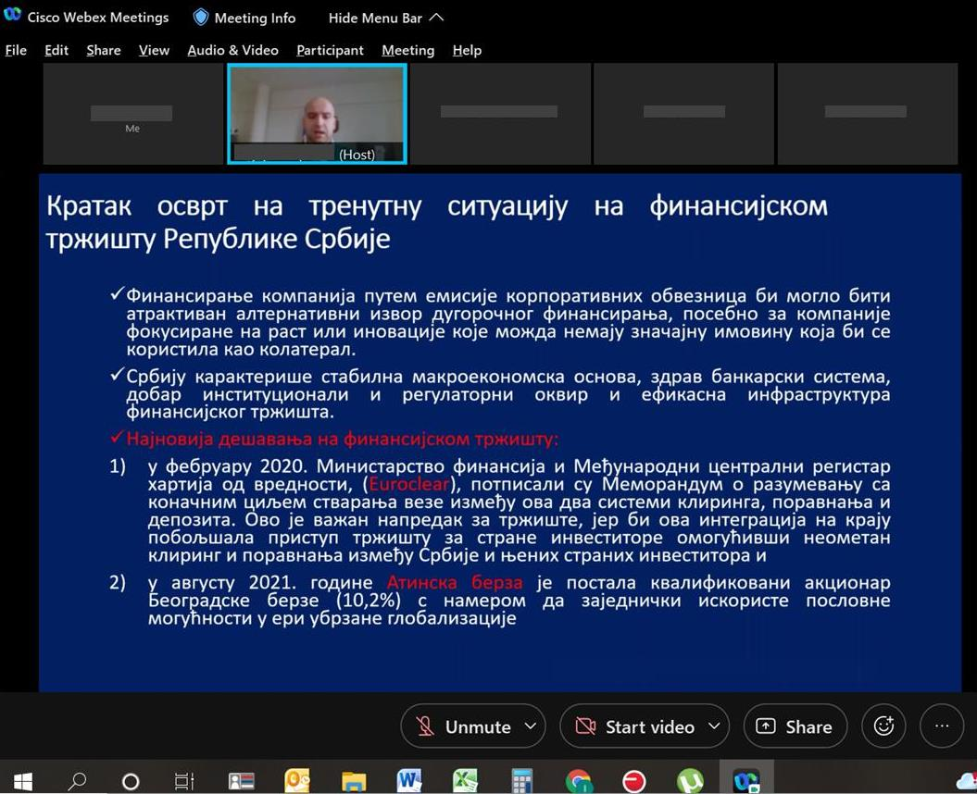Picture 1: On-line Public consultation in Belgrade, 21 December 2021
Special focus was given to project description, implementation arrangements, potential environmental and social impacts, grievance redress procedures, labor management, screening forms and development of environmental and social management plans during Project implementation.
The importance of labor management and most important provisions of WB Environmental and Social Standard ESS2: Labor and Working Conditions were also explained to the public during presentation of ESF documents.
There were no questions nor comments raised by the attendees during Public Consultations and Public presentation of ESF documents.

DOCUMENTATION

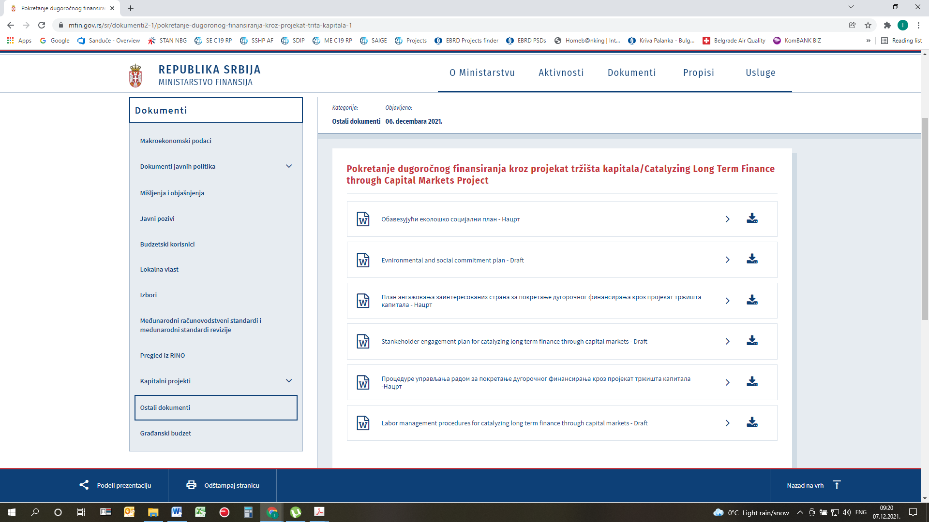
Picture 2: Public disclosure of Draft ESCP, SEP, LMP and ES Procedure on Ministry web site

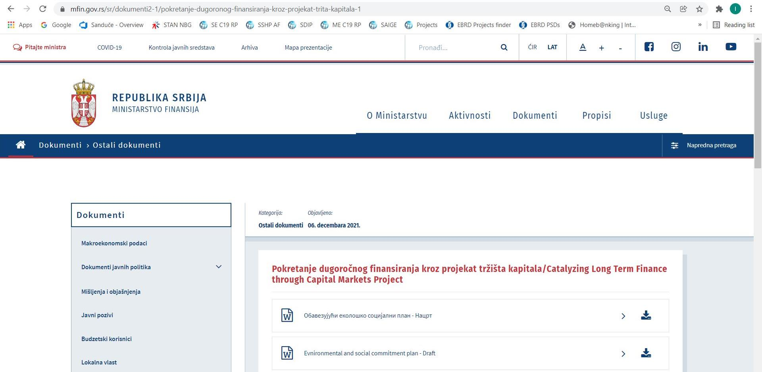
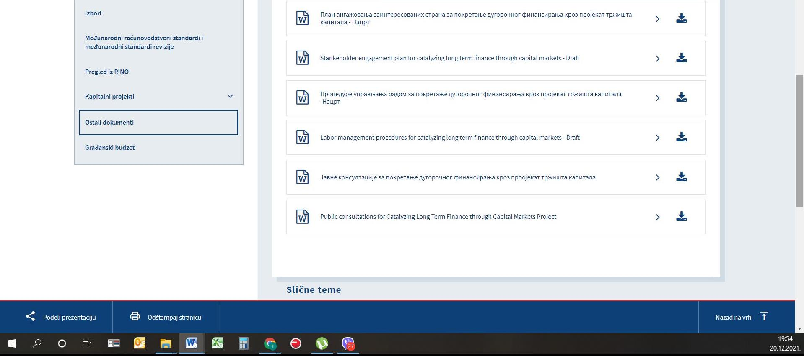
Picture 3: Announcement of public consultation on CLTFTCM Environmental documents on Ministry web site
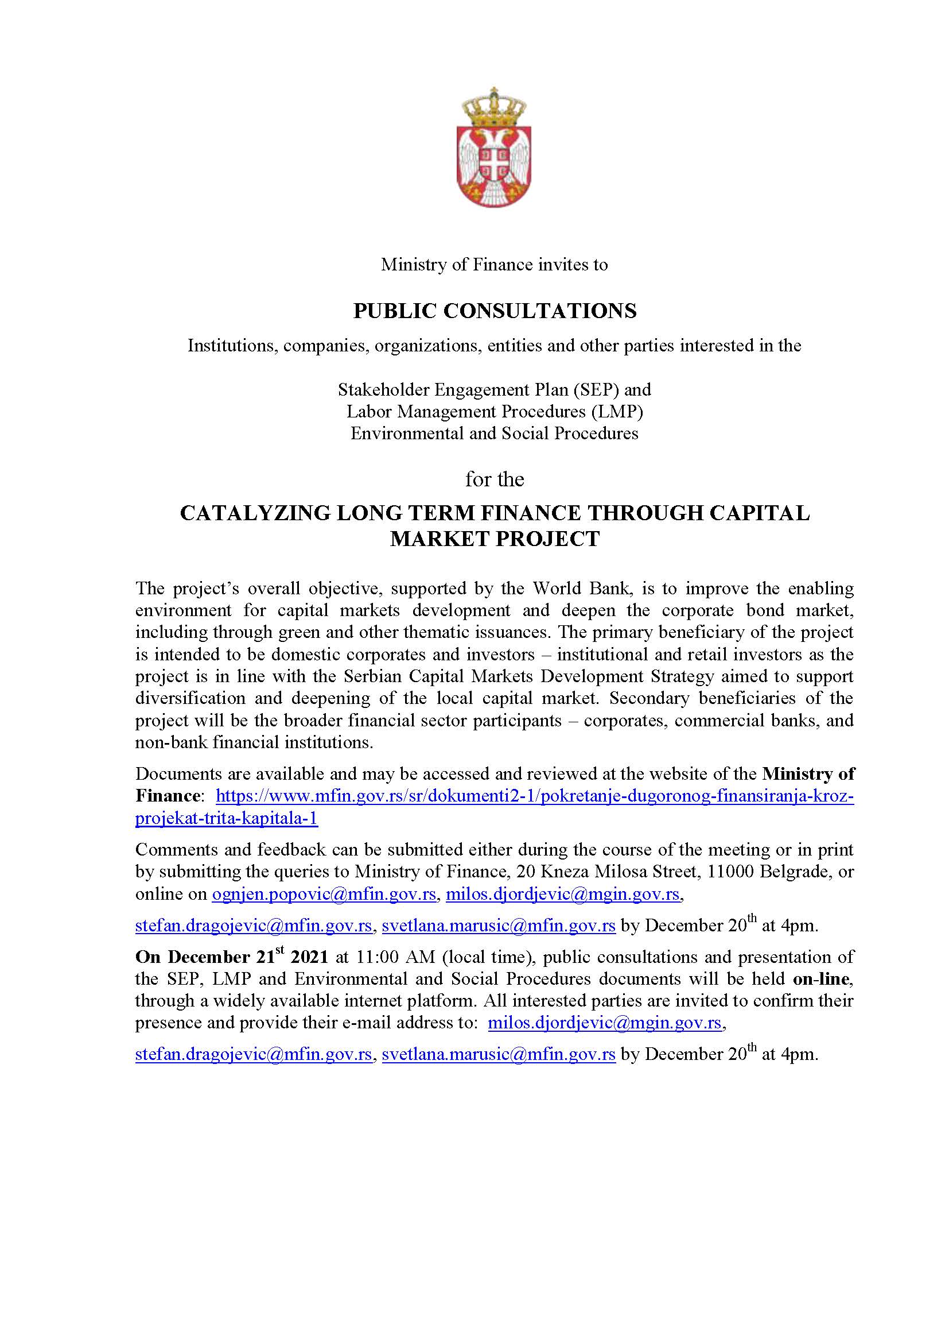
Picture 4: Announcement of public consultation on CLTFTCM Environmental documents on Ministry web site

Thematic bonds are instruments that contribute toward broad ESG-related goals and objectives and are labeled as such. Climate financing is a particular focus for thematic issuances. Thematic bonds may include instruments in which the proceeds are earmarked for specific purposes (e.g., green, social, or sustainability bonds), as well as those for which the financial and/or structural characteristics vary depending on whether the issuer achieves predefined sustainability or ESG objectives (sustainability-linked bonds). These bonds follow internationally accepted standards and principles, including use of proceeds, selection of projects, monitoring and reporting, sustainability performance targets, and key performance indicators. Non-labeled instruments may or may not specifically earmark proceeds for ESG purposes or follow generally accepted standards. Source: World Bank, 2020. “Engaging with Investors on Environmental, Social and Governance (ESG) Issues - A World Bank Guide for Sovereign Debt Managers,” https://thedocs.worldbank.org/en/doc/375981604591250621-0340022020/original/WorldBankESGGuide2020FINAL.11.5.2020.pdf
The One-Stop Shop will be housed in the MoF under the Department for Digitalization in the area of Finance.
Sri Lanka Securities and Exchange Commission: https://www.sec.gov.lk/)
The sectors which have been preliminarily identified with the highest possibility of near-term corporate bond issuance are within the construction and housing sectors. The expectation is over time other sectors would also be more active in the corporate bond market, including the banking sector.
World Bank: Serbia – State-Owned Financial Institutions Strengthening Project (P156837) and Serbia – Deposit Insurance Strengthening Project (P146248).
The ESF is accessible at - https://www.worldbank.org/en/projects-operations/environmental-and-social-framework. latest accessed on July 21, 2020
https://www.mfin.gov.rs/sr/dokumenti2-1/pokretanje-dugoronog-finansiranja-kroz-projekat-trita-kapitala-1
https://worldbankgroup.sharepoint.com/sites/wbunits/opcs/Knowledge%20Base/Public%20Consultations%20in%20WB%20Operations.pdf

